FIA Continued Trust in YOKOHAMA -
New contract awarded as official tyre supplier for WTCC.

The Yokohama Rubber Co. Ltd, announced today that it would continue to supply its global flagship brand "ADVAN" tyre as control tyres for the FIA World Touring Car Championship (WTCC) through to 2015.

YOKOHAMA has been the official tyre supplier to the WTCC since 2006, and the performance of its ADVAN racing tyres has been highly evaluated by the FIA. ADVAN racing tyres meet all of the FIA's stringent sporting and technical requirements, and the FIA has decided to extend the contract for another 3 years.

WTCC is one of the World Championships sanctioned by FIA, along with Formula 1 (F1) and the World Rally Championship (WRC). It is the world's premier touring car race which counts with the participation of leading car manufacturers including Chevrolet, BMW and Ford.

From this year Honda have also committed to participating in the asian rounds of the WTCC as a precursor to joining the full championship in 2013 as well as Russian manufacturer Lada, who have joined some of the European rounds and will now also consider wider participation in 2013.

For its part, YOKOHAMA Europe, will continue its promotional and support activities at all WTCC European rounds.

WTCC events are staged all over the world, mainly in Europe but also in Africa, Latin America, North America and Asia.

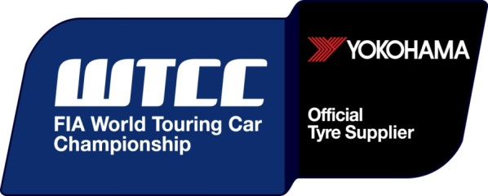

Notes to Editors
YOKOHAMA is one of the leading Tyre manufacturers in the world and is Official Tyre supplier for;
FIA World Touring Car Championship (WTCC) – since 2006
European Touring Car Cup (ETCC) – since 2005
Intercontinental Rally Challenge (IRC) – since 2007
Scandinavian Touring Car Championship (STCC) – since 2010
Russian Touring Car Championship (RTCC) – since 2006
Chinese Touring Car Championship (CTCC) – since 2010
Irish Touring Car Championship (ITCC) – new for 2012
International Formula 3 Grand Prix Macau – since 1983
ATS German Formula 3 – until 2005 and since 2007
FIA F2 Championship – new for 2012
Japanese Formula 3 – since 2011
ADAC GT Masters new for 2012
GT Asia new for 2012

