10th January 2020

Yokohama’s classic tyres take centre stage at Autosport International

• 1964 Monte Carlo Rally winner Paddy Hopkirk visits Yokohama at Autosport International (UK)

• Hobby tyre range highlights Yokohama’s enduring high-performance credentials

• Yokohama hobby tyre range combines modern technology and classic style

Yokohama’s recently launched range of hobby tyres for classic cars took centre stage on the company’s stand at this year’s Autosport International show in Birmingham.
With interest in classic cars reaching record levels, Yokohama is leading the way with the revival of some of its heritage brands, providing drivers of historic cars with tyres that incorporate modern technology and performance while retaining the classic style and design from the 1960s and beyond.

“While we continue to focus much of our efforts and attention on the cars of today and tomorrow, we’re equally proud to provide the many passionate owners and enthusiasts of classic cars with our dedicated range of hobby tyres which complement their vehicles perfectly,” explains David Seward, managing director, Yokohama HPT. “Classic tyres form an important element of our comprehensive premium tyre strategy to deliver the very best products for race, road and off-road vehicles, and we look forward to showcasing these further throughout 2020.”

As part of Yokohama’s promotion of its hobby tyre range, they were joined on their stand by rallying legend Paddy Hopkirk who took victory in the 1964 Monte Carol rally. Hopkirk posed alongside a recreation of his iconic winning Mini, fitted with Yokohama’s popular ADVAN HF Type-D A008 tyre which is currently available in sizes from 10” to 15”.

Also available within Yokohama’s hobby tyre range include the new 16” ADVAN A008P which was originally developed as the OE tyre fitted on the Porsche 911 Carerra Turbo (930), Carrera 2, Carrera 4 models, the GT Special (Y350) available in period correct 80 profile, 14” and 15” sizes, and the classic A539 pattern in sizes from 12” to 14”.

Yokohama will continue the promotion of its hobby tyre range at various events during 2020 including at the Silverstone Classic, Europe’s biggest classic motor racing festival, where it will return once again as the official tyre partner.

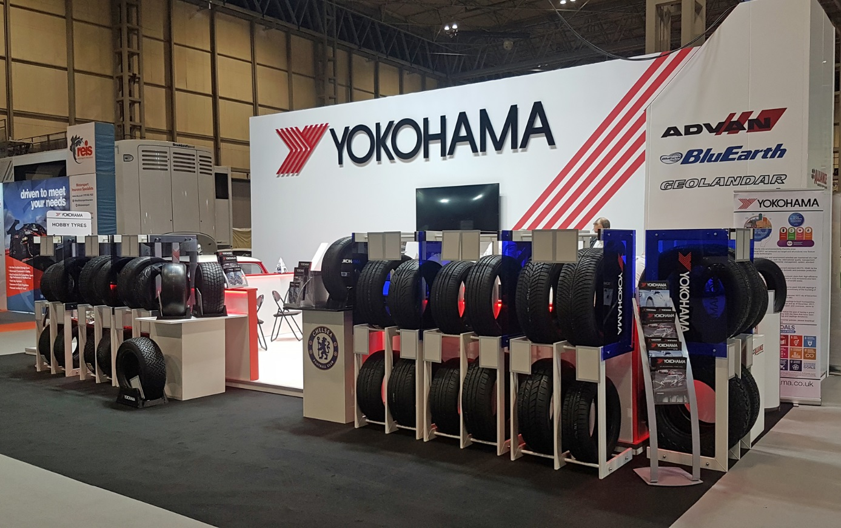
Autosport International 2020

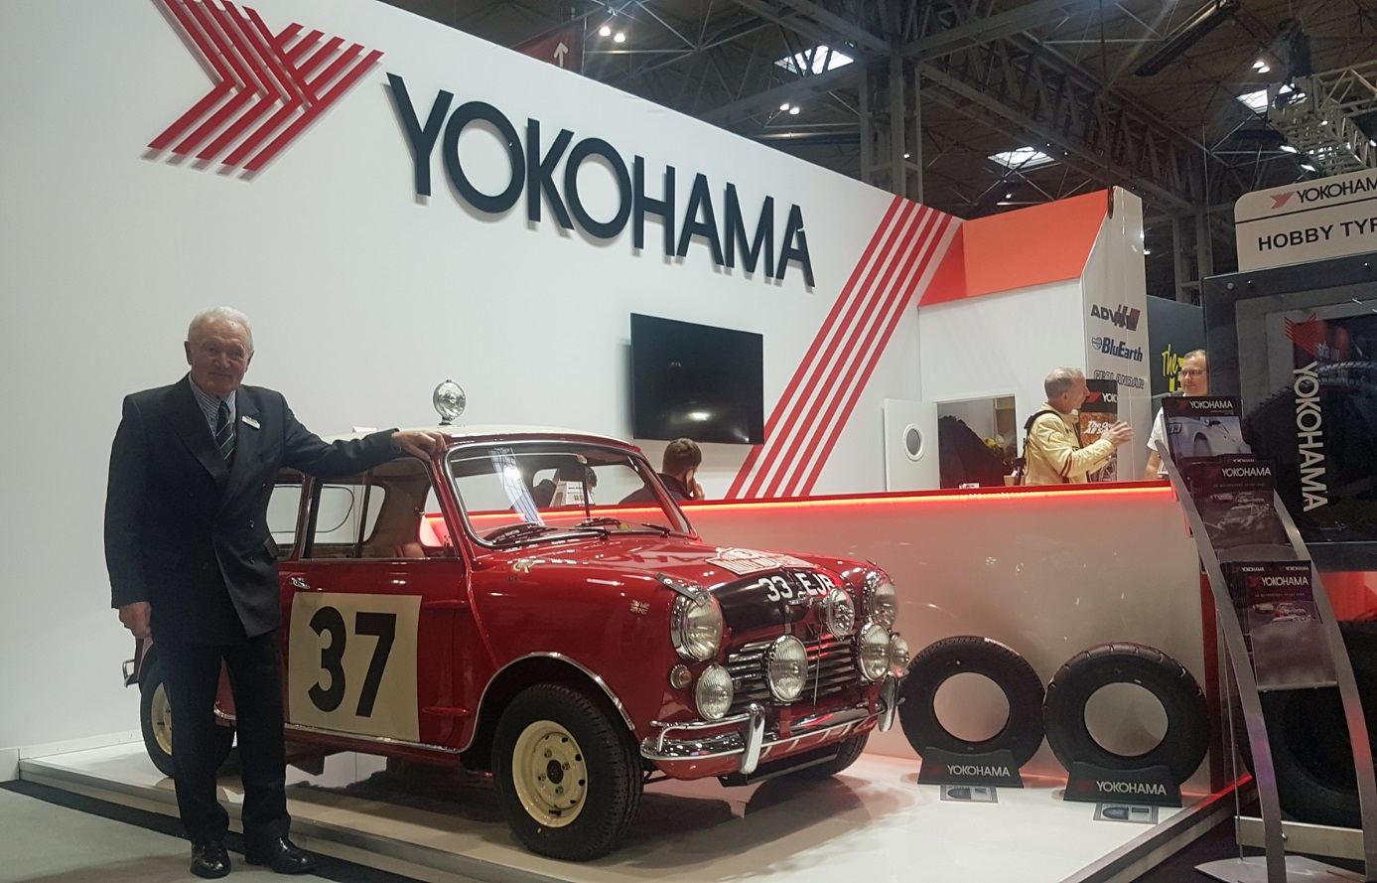
Paddy Hopkirk

