5th July 2021

YOKOHAMA tyre–equipped cars capture championships in two divisions in US’s most challenging hill climb

YOKOHAMA is pleased to announce that cars running on its global flagship ADVAN brand tyres finished first in two divisions* at the 99th Pikes Peak International Hill Climb held in Colorado, USA, on 27th June. YOKOHAMA supplied its “ADVAN A005” and “ADVAN A052” tyres.

The two division champions were Raphael Astier, driving a 2015 Porsche BBI Turbo Cup in the Pikes Peak Open Division, and Randy Pobst, driving his 2021 Tesla Model S Plaid in the Exhibition Division. In addition to the two division winners, Codie Vahsholtz finished second in the Open Wheel division, competing in the same 2013 Ford Open car that his father Clint drove when capturing the overall championship at Pikes Peak last year. Also a car equipped with YOKOHAMA tyres finish third in the Time Attack 1 division. Meanwhile, Tanner Foust finished first in the Porsche Pikes Peak Trophy by Yokohama division, in which all entrants compete in Porsche Cayman GT4 Clubsport equipped with “ADVAN A052” tyres.

The Pikes Peak International Hill Climb is a hill climb competition with a long and illustrious history dating back to 1916. It is also known as the “Race to the Clouds” as the course starts at an elevation of 2,862 meters and covers about 20 kilometers before reaching the finish line at an altitude of 4,300 meters. Cars competing in past competitions on YOKOHAMA tyres included a YOKOHAMA-supported electric vehicle (EV) that captured the class championship for three years in a row from 2010 to 2012, setting new time records for EVs in each of those years. Also, as noted above, Clint Vahsholtz captured last year’s overall championship in his 2013 Ford Open equipped with “ADVAN A005” tyres.

The consumer tyre business in YOKOHAMA’s new three-year (2021–2023) medium-term management plan, Yokohama Transformation 2023 (YX2023), aims to maximize the sales ratios of high-value-added YOKOHAMA tyres, namely the global flagship ADVAN brand, the GEOLANDAR brand of tyres for SUVs and pickup trucks, and various winter tyres. YX2023 positions participation in motorsports activities as crucial to the company’s effort to develop new tyre technologies that will further strengthen the ADVAN and GEOLANDAR brands. YOKOHAMA therefore is again participating in a wide variety of motorsports events in Japan and around the globe, from top-category to grassroots events.

*Excluding the Porsche Pikes Peak Trophy by Yokohama division, a one-make competition in which all cars are equipped with YOKOHAMA tyres.

Notable results for drivers/cars using YOKOHAMA tyres 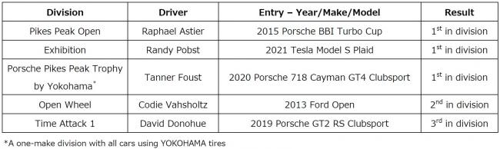

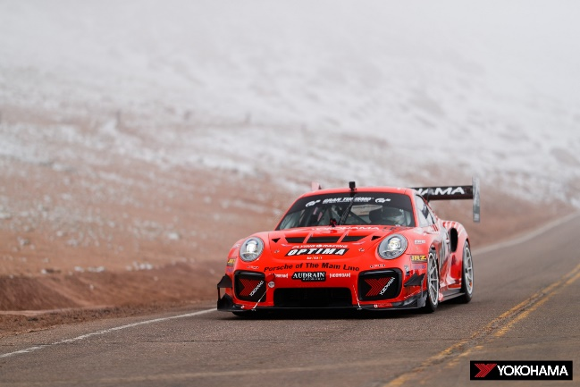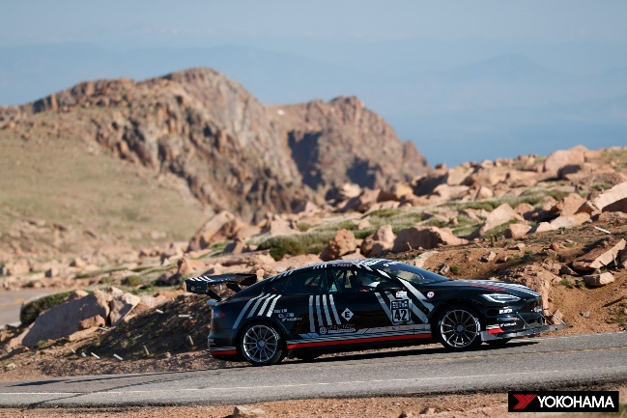
The 2015 Porsche BBI Turbo Cup driven The 2021 Tesla Model S Plaid driven to victory in
to victory by Raphael Astier the Exhibition division by Randy Pobst
in the Pikes Peak Open division

