15th December 2022

YOKOHAMA to supply racing tyres with a sustainable material content ratio of 33% for 2023 SUPER FORMULA races

YOKOHAMA announced today that it will supply ADVAN racing tyres with a sustainable material content as the control tyre for the Japanese SUPER FORMULA Championship (hereafter, SUPER FORMULA) from the 2023 season. The company has completed development of tyres for use in dry conditions and will continue developing tyres for wet conditions with the aim of supplying them from 2023.

The dry condition tyres being supplied by YOKOHAMA use natural rubber and various naturally
derived compounding agents including oil produced from oil palm nuts and orange peels, as well as recycled iron, rubber recycled from waste tyres, and synthetic rubber produced using the mass balance method*. As a result, sustainable materials account for about 33% of all materials used in the tyres, which have demonstrated performance equivalent to that of the standard tyres used in SUPER FORMULA 2022 races.

*A method that allows you to label a commercial product as a biomass-derived product based on the volume of biomass-derived raw materials used during the process of turning raw materials into final products and the distribution process. Commercial products labelled as biomass-derived raw products therefore are regarded as fully biomass-derived regardless of their actual volume of biomass-derived materials.

Racing tyres made from sustainable materials will be supplied in support of the SUPER FORMULA NEXT 50 (SF NEXT 50) project announced in October 2021 by Japan Race Promotion Inc., which runs the SUPER FORMULA series. The SF NEXT 50 project is being promoted with the cooperation of various companies that share the common goal of creating a sustainable motorsports industry by responding to changes in the environment surrounding the automobile and motorsports industries, including the promotion of SDGs and carbon neutrality.

Aiming to develop racing tyres that include sustainable materials without compromising driving
performance, YOKOHAMA tested its tyres as part of the trial runs for next-generation formula
cars that were held before and after each Super Formula race during the 2022 season. The company will continue its efforts to develop tyres with higher sustainable material content in 2023 and coming years.

Under YOKOHAMA’s three-year (2021–2023) medium-term management plan YX2023, the consumer t re business aims to maximize the sales ratios of high-value-added YOKOHAMA tyres, namely the global flagship ADVAN brand, the GEOLANDAR brand of tyres for SUVs and pick-up trucks, and various winter tyres. The plan also positions participation in motorsports activities as crucial to YOKOHAMA’s development of advanced tyre technologies and strengthening of its ADVAN and GEOLANDAR brands. The company’s development of high-performance and top-quality tyres for new cars and the replacement market benefits from the technologies accumulated through its participation in a wide variety of motorsports events in Japan and around the globe, from top-category races to grassroots races. YOKOHAMA also is promoting sustainability initiatives based on the concept of “Caring for the Future.” The company believes that conducting its business activities aligned with these sustainability initiatives will help resolve social issues and lead to the continued increase of its corporate value. One goal of YOKOHAMA’s sustainability initiatives is to contribute to the realization of a circular economy. Toward that end, YOKOHAMA aims to increase the ratio of renewable and recyclable materials used by the company to more than 30% of total materials used by 2030 and then raise that ratio to 100% in 2050.
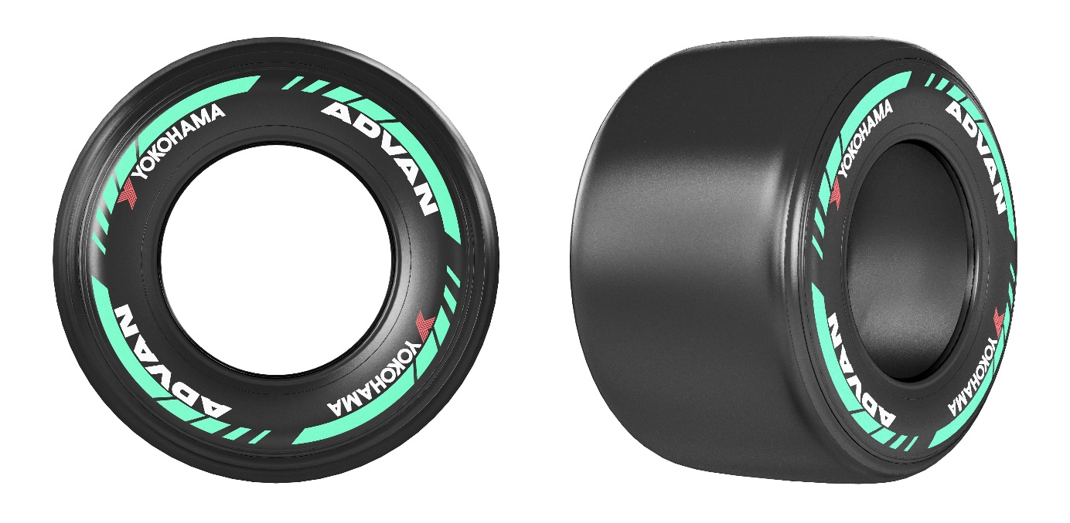
ADVAN racing tyres (dry use) to be supplied to SUPER FORMULA races from 2023

Progress in development of ADVAN racing tyres using sustainable materials during 2022

1st test: April 6–7 (Fuji Speedway)

Tests runs were made by cars fitted with four different ratios of sustainable materials used in the compounds and in the casings that form the tyre’s construction. The results showed that tyres with higher ratios of sustainable materials performed just as well as the standard tyres being used in the 2022 season.

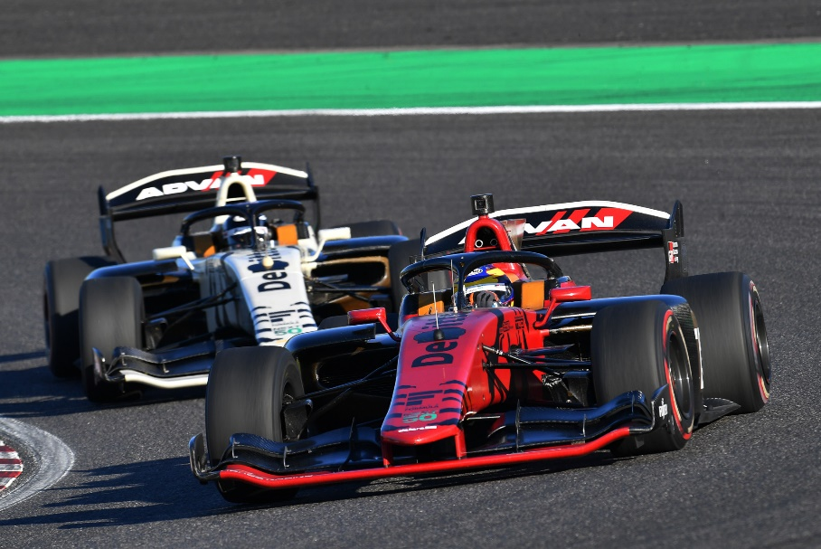
SUPER FORMULA 2023 will feature new formula cars

2nd test: April 25–26 (Suzuka Circuit)

The 2nd test compared tyres with eight different sustainable material ratios with the standard racing tyres used in the 2022 season. Long runs on the demanding Suzuka Circuit course and its technical high-speed corners that place a particularly high load on tyres confirmed the tyres’ durability and suitability for use on next-generation formula cars featuring new aerodynamics.

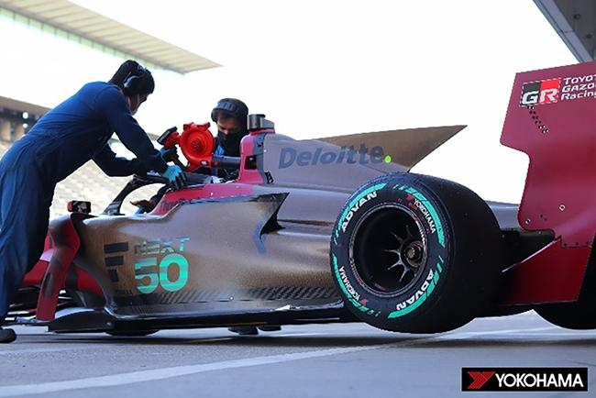
Development car with lower downforce than SF19 cars

3rd test: May 18–19 (Autopolis)

During the 3rd test, tyres made with combinations of casings and compounds that performed well in previous tests were tested on the Autopolis course with different features that presented new challenges. In addition to the two compounds used in tyres tested to date, 3rd test evaluated a new reconfigured third compound. In addition to completing the entire planned test menu and obtaining a large amount of data, the 3rd test also saw the tyres tested over a long distance similar to the length of a SUPER FORMULA race.

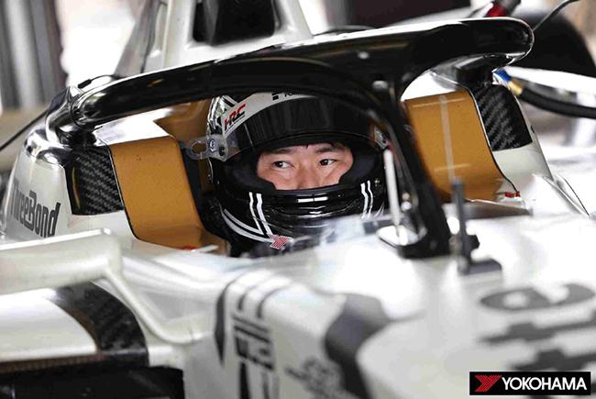
Test driver Koudai Tsukakoshi

4th test: June 20–21 (Sportsland SUGO)

The 4th test was carried out on a narrowed down group of previously tested casing/compound combinations to get a sense of how different they feel on different circuits. Steadily narrowing down the group of casing/compound combinations being evaluated enabled testing to focus on the tyres’ performance on long runs, which made possible evaluations of wear when the tyres are subjected to high-temperature conditions.

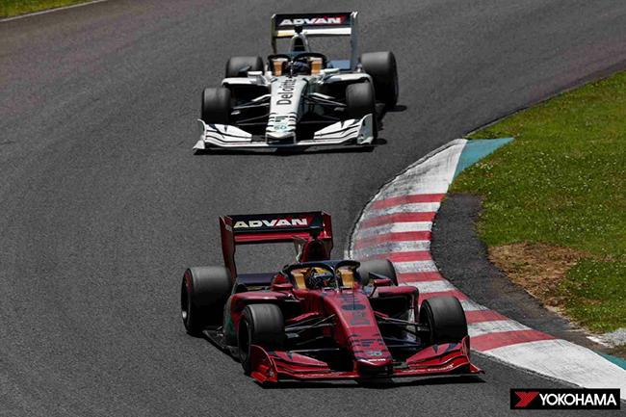
Long run test scene

5th test: July 18–19 (Fuji Speedway)

Rain on the second day of the 5th test provided the first opportunity to test the tyres on a wet track. Morning tests were conducted during light rain on a damp track, and heavier rain in the afternoon made it possible to compare the tyres’ performance in light rain with their performance in wetter conditions caused by heavier rainfall. Long-running tests also were conducted, and the 5th test generated valuable wet condition data.

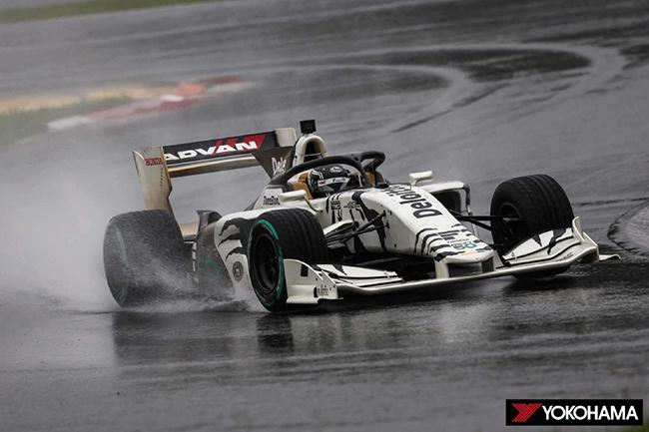
Test run on wet track

6th test: October 26–27 (Suzuka Circuit)

In preparation for the carbon neutral standards to be introduced in the SUPER FORMULA 2023 season, the 6th test was conducted on tyres with casing and compound specifications narrowed down based on results to date on fully updated new SF23 cars. Test driver comments about which tyres performed as well as the standard tyres being used in 2022 races contributed to the final decision on the specs for new dry condition racing tyres.
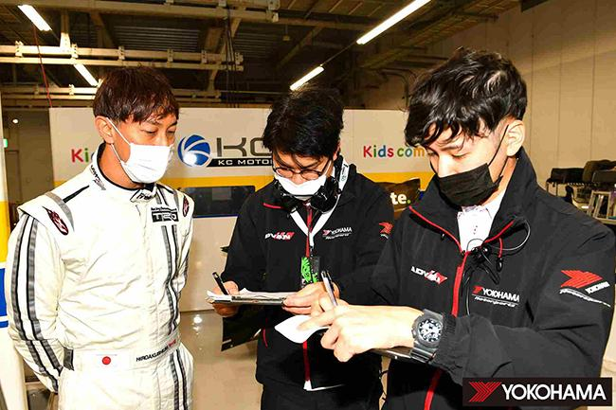
Test driver Hiroaki Ishiura (left) speaking to YOKOHAMA tyre development staff

7th test: November 21–22 (Mobility Resort Motegi)

On Day 1, testing was conducted on a track surface sprinkled with water to determine optimal specifications for wet condition tyres. Test subjects included tyres with three different specifications modified from the specs that had performed well in the rain at Fuji Speedway in July, and the results were compared with the performance of the standard tyres being used in 2022 season races. Future testing will be conducted on a narrower range of specifications with the aim of developing wet tyre specs for use in 2023. Day 2 testing focused on evaluating the performance of dry condition tyres on which development had been advanced to include a higher ratio of sustainable raw materials.

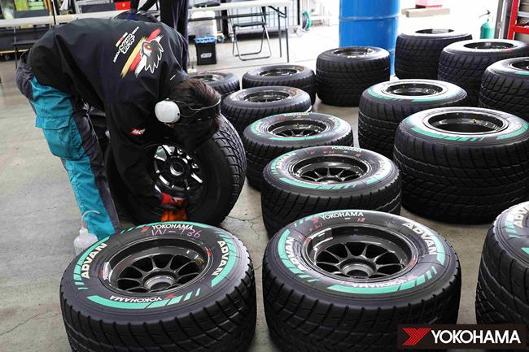
Tested wet-condition tyres

