26th July 2023

YOKOHAMA to supply GEOLANDAR tyres to TOYOTA GAZOO Racing Indonesia in this year’s AXCR

YOKOHAMA announced today that it will supply its GEOLANDAR M/T G003 mud-terrain tyres for SUVs and pick-up trucks to TOYOTA GAZOO Racing Indonesia entered in this year’s Asia Cross Country Rally (hereafter AXCR), Asia’s largest cross country rally, which is scheduled to be held during August 13–19.

YOKOHAMA will supply its GEOLANDAR M/T G003 tyres for three TOYOTA GAZOO Racing Indonesia team vehicles being driven by Takuma Aoki, Ikuo Hanawa, and Tubagus Adhi Moerinsyahdi. Aoki and Hanawa also participated as TOYOTA GAZOO Racing Indonesia drivers in last year’s AXCR, respectively finishing in fourth place and third place in Toyota Fortuner SUVs fitted with GEOLANDAR M/T G003 tyres. This year they will once again race in Toyota Fortuner SUVs.

Takuma Aoki has been active in rally car racing for many years, especially in the overseas rally circuit. He has participated in AXCR events with Yokohama Rubber’s support since 2007. He has an outstanding record in the AXCR, including a third-place finish in 2011 and fourth place in 2022, both times driving cars running on GEOLANDAR tyres. Ikuo Hanawa is a world-class off-road racer representing Japan. Participating with support from YOKOHAMA, Hanawa raced to a second-place finish in Class 7 at the 2022 Mint 400, the oldest off-road race in the United States.

GEOLANDAR M/T G003 tyres captured the overall championship in last year’s AXCR, and YOKOHAMA is again providing its tyres in support of several teams from various countries as it looks forward to a second straight overall championship for a vehicle running on GEOLANDAR tyres.

YOKOHAMA’s GEOLANDAR M/T G003 tyres deliver superior performance on the full range of off-road surfaces over an exceptionally long lifespan. In addition, the tyre features a sturdy and aggressive design that enhances the off-road driving sensation. YOKOHAMA’s GEOLANDAR brand tyres, including the M/T G003, are widely used in motorsports and have performed brilliantly in many of the most demanding off-road races in Asia, North America, and other regions.

First held in 1996, AXCR is an FIA (Federation Internationale de l’Automobile) officially sanctioned race, similar to the Dakar Rally. In recent years, the AXCR has been run over a different course each year, with the starting line in Thailand and then passing through many Southeast Asian countries as it winds through a diverse range of terrains, from mountains and jungles to beaches and plantations, and even race circuits. This year’s rally will start in Thailand and finish some 2,000kms away in Laos.

Under YOKOHAMA’s three-year (2021–2023) medium-term management plan, Yokohama Transformation 2023 (YX2023), the consumer tyre business aims to maximize the sales ratios of high-value-added YOKOHAMA tyres, namely the global flagship ADVAN brand, the GEOLANDAR brand of tyres for SUVs and pick-up trucks, and various winter tyres. As part of its 2023 “Mud Match” themed sales campaign, the consumer tyre business is introducing new tyres in its GEOLANDAR brand and accelerating the expansion of the size line-ups. YX2023 also positions participation in motorsports activities as crucial to the company’s effort to develop new tyre technologies that will further strengthen the ADVAN and GEOLANDAR brands. YOKOHAMA therefore is again participating in a wide variety of motorsports events in Japan and around the globe, from top-category to grassroots events.

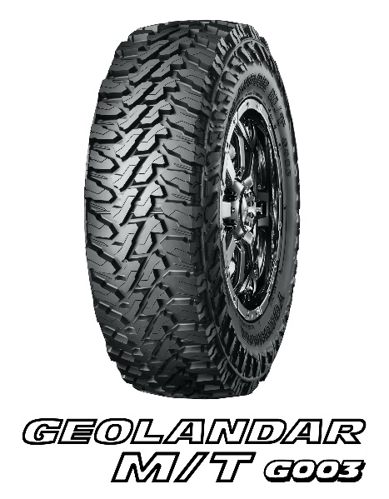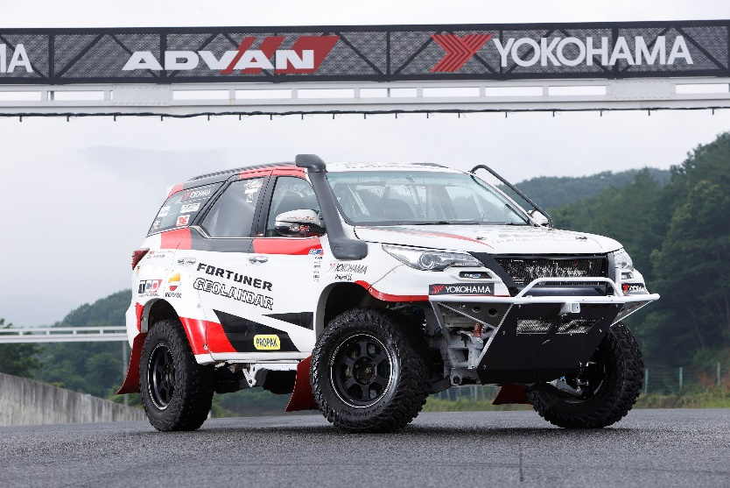
Takuma Aoki’s Toyota Fortuner

