5th October 2023

YOKOHAMA to launch the GEOLANDAR CV 4S, an all-season tyre for crossover SUVs

YOKOHAMA today introduces the GEOLANDAR CV 4S, a new all-season tyre for crossover SUVs. The latest addition to the GEOLANDAR brand of tyres for SUVs and pick-up trucks, the GEOLANDAR CV 4S will be launched from this autumn in North America, Europe and then South Korea. The new tyre will be available in 32 sizes, ranging from 245/45R20 103V to 235/65R17 108V.

YOKOHAMA developed the GEOLANDAR CV 4S in response to the annually growing worldwide demand for tyres for crossover SUVs. A newly developed asymmetric tread pattern and compound contribute to the tyre’s excellent performance in wet conditions and on snow, as well as on dry roads. All 32 sizes have received the M+S (mud & snow) designation that indicates they will deliver excellent performance in a sudden snowfall as well as the Three-Peak Mountain Snowflake Symbol* applied to tyres that meet international standards for tyres to be used in severe snow.
*The Three-Peak Mountain Snowflake Symbol is a mark certifying winter tyres for use in Europe.

All-season tyres are appropriate for driving on almost all road conditions, from dry and wet roads to snowy roads, making them suitable for use in all climates. As they can be used year round, including during sudden snowfalls, all-season tyres eliminate the need for seasonal tyre changes and a place to store out-of-season seasonal tyres, thus enhancing user convenience.

Under the GEOLANDAR brand, YOKOHAMA is developing SUV tyres suitable for use on a wide range of road surfaces, from highway terrain to mud terrain. GEOLANDAR brand tyres already on the market include the GEOLANDAR CV G058, a grand-touring tyre for crossover SUVs, the GEOLANDAR X-CV for high-performance crossover SUVs, and the GEOLANDAR H/T G056 for midsize and large SUVs. The new GEOLANDAR CV 4S enhances the brand’s ability to meet the diversifying needs of SUV owners.

Under YOKOHAMA’s three-year (2021–2023) medium-term management plan, Yokohama Transformation 2023 (YX2023), the consumer tyre business aims to maximize the sales ratios of high-value-added YOKOHAMA tyres, namely the global flagship ADVAN brand, the GEOLANDAR brand of tyres for SUVs and pick-up trucks, and various winter tyres. Under its “Mud Match” themed campaign focused on expanding sales of GEOLANDAR tyres, YOKOHAMA has been introducing new tyres, such as the new GEOLANDAR CV 4S and the GEOLANDAR A/T XD launched this March in North America and Australia, and expanding the size line-ups of GEOLANDAR tyres already on the market.
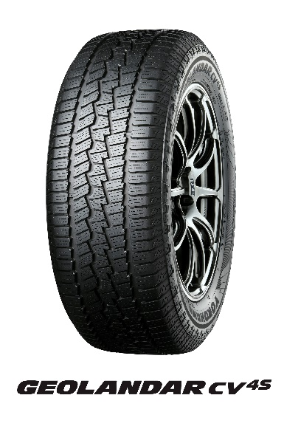

Available Sizes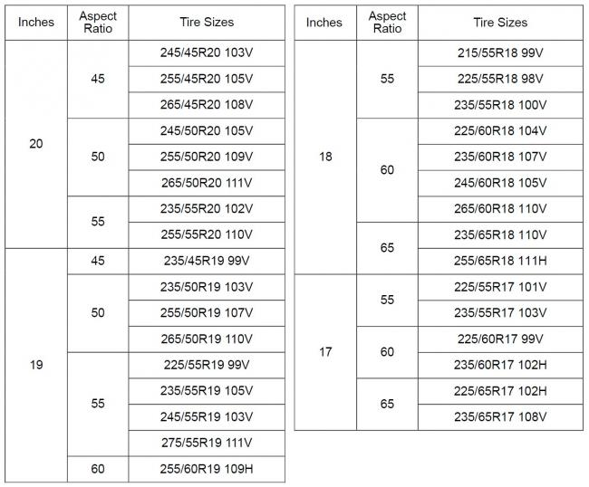

Tread Pattern Technology
1) The specially developed asymmetric tread pattern’s increased void ratio on the inner portion of the tyre improves drainage while the aggressive block pattern increases traction. Large contact area on the outer portion and ribbed blocks enhance steering stability.

2) Four zig-zag grooves include two outer grooves with wide widths that facilitate water drainage and a zig-zag shape that increases traction in snow. Meanwhile, the two narrow inner grooves increase edging efficiency and further enhance traction in snow.

3) Optimized lug grooves improve the tyres´ snow removal and water dispersal, contributing to stronger traction on wet and snowy roads.

4) 3D-shaped sipes contribute to the tyre’s wear resistance and dry performance by suppressing tread block collapse and strengthening the tyres´ edges and rigidity.

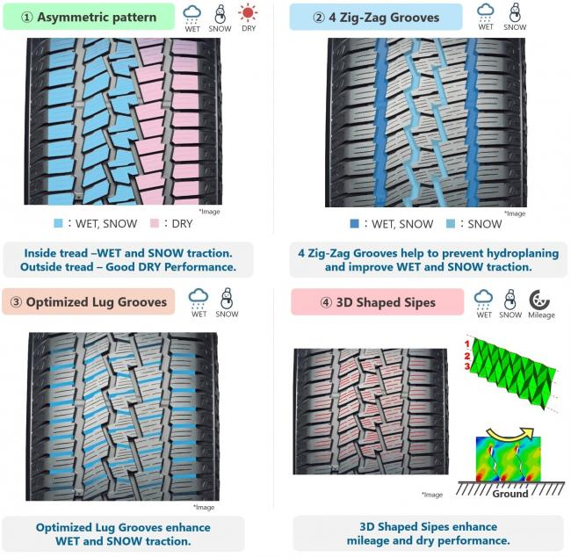

Compound Technology
The compound is infused with micro silica to improve dry performance and handling stability, while the new polymer blend improves traction on dry, wet, and snow-covered surfaces.

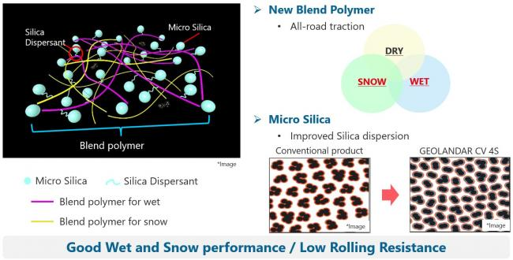

Product Design

