29th February 2024
YOKOHAMA supporting WRC champion Kalle Rovanperä in FORMULA DRIFT JAPAN opening round
YOKOHAMA announced today that it will be supplying its global flagship ADVAN brand tyres and wheels to Kalle Rovanperä for his participation in the opening round of this year’s FORMULA DRIFT® JAPAN (hereafter, FDJ), to be held on April 6-7 at the Fuji International Speedway in Shizuoka Prefecture. Rovanperä will be participating in the Red Bull GR COROLLA from KR69 CUSCO Racing.
Kalle Rovanperä is a rally driver from Finland. Having mastered drifting techniques at the age of eight, Rovanperä has deep knowledge of drift competition and has participated in the Drift Masters European Championship series. He began full participation in the World Rally Championship (WRC) in 2020 as a driver for the TOYOTA GAZOO Racing World Rally Team. He finished the 2021 season with two victories and an overall fourth place driver’s ranking and won the drivers’ championship in 2022 and 2023.
YOKOHAMA will be supplying Rovanperä with the ADVAN NEOVA AD09, YOKOHAMA’s ultimate street custom-tuned tyres, which has a well-balanced combination of enhanced levels of dry grip, controllability, and wear resistance. The supplied tyres will come fitted with ADVAN Racing GT BEYOND aluminium sports wheels. YOKOHAMA expects its support for Kalle Rovanperä, who is attracting global attention as a phenomenal young driver competing in drifting competitions that require the most advanced techniques, to help raise recognition of the ADVAN brand as a tyre with superior performance.
FDJ is an international version of the FORMULA DRIFT® series held in the United States. FDJ, held since 2014, essentially is a reverse import from the US FORMULA DRIFT®, which has elevated the popularity of drift driving, a motorsport that originated in Japan.
The consumer tyre strategy in YOKOHAMA’s new three-year (2024–2026) medium-term management plan, Yokohama Transformation 2026 (YX2026), aims to maximize the sales ratios of high-value-added tyres by expanding sales of YOKOHAMA’s global flagship ADVAN brand, the GEOLANDAR brand of tyres for SUVs and pick-up trucks, winter tyres, and 18-inch and larger tyres. YOKOHAMA positions participation in motorsports activities as crucial to its effort to further strengthen the ADVAN and GEOLANDAR brands. YOKOHAMA therefore is again participating in a wide variety of motorsports events around the globe, from top-category to grassroots events.
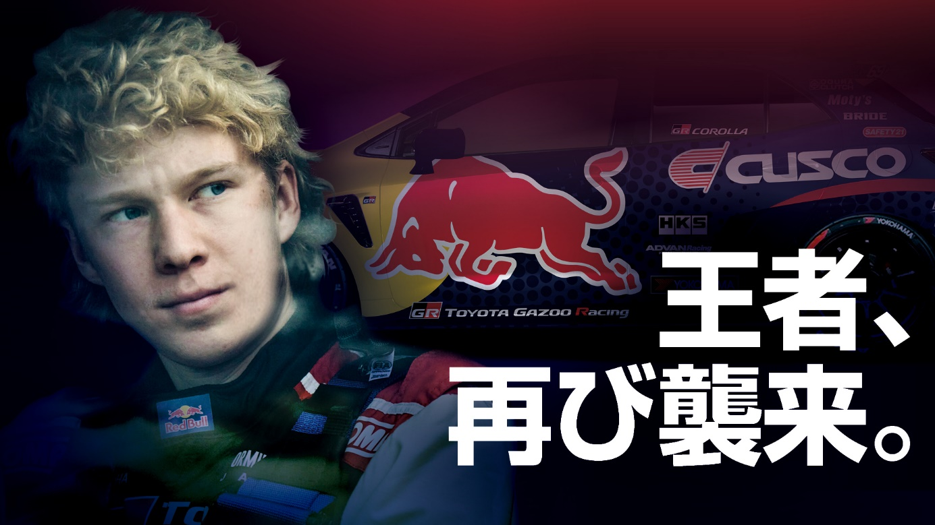A visual announcing Rovanperä’s rematch in FDJ

