18th April 2022

YOKOHAMA supporting Daigo Saito in FORMULA DRIFT® Japan and D1 GRAND PRIX Series

YOKOHAMA announced today that it will support professional drifting driver Daigo Saito, who is competing in the FORMULA DRIFT® JAPAN (hereafter, FDJ) and D1 GRAND PRIX (D1GP) series. The Company will be supplying Saito with its ADVAN NEOVA AD09 high-performance street tyres.

FDJ was launched in 2015 as an international series of the FORMULA DRIFT® series, a popular drift competition that has been held in the United States since 2004. The D1GP is Japan’s ultimate drift competition series that began in 2000. This year’s FDJ will feature six rounds, and the D1GP series will include nine rounds. As the inaugural competition for each series is on the same day this April, Daigo Saito will be participating in the FDJ.

Daigo Saito is a world-class drift driver who started his drifting career in Japan and competed in multiple countries all over the world. Saito is widely recognized among drift fans as the only driver to be crowned champion of the world's two largest drift series - having won the FORMULA DRIFT® USA championship in 2012 and the D1GP series in 2008 and 2016.

The supplied tyres are the ADVAN NEOVA AD09 which are YOKOHAMA’s strongest custom-tuning tyre. These tyres are fine-tuned to deliver higher levels of dry grip, controllability, and wear resistance. The former model of the street sport tyre ADVAN NEOVA AD08R were the control tyre for the 2021 season of the FDJ2, which is the second division of FDJ. YOKOHAMA will continue supplying the FDJ2 series competitors with the new ADVAN NEOVA AD09 as the series control tyre.

Under YOKOHAMA’s three-year (2021–2023) medium-term management plan, Yokohama Transformation 2023 (YX2023), the consumer tyre business aims to maximize the sales ratios of high-value-added YOKOHAMA tyres, namely the global flagship ADVAN brand, the GEOLANDAR brand of tyres for SUVs and pick-up trucks, and various winter tyres. YX2023 also positions participation in motorsports activities as crucial to the company’s effort to develop new tyre technologies that will further strengthen the ADVAN and GEOLANDAR brands. YOKOHAMA therefore is again participating in a wide variety of motorsports events in Japan and around the globe, from top-category to grassroots events.

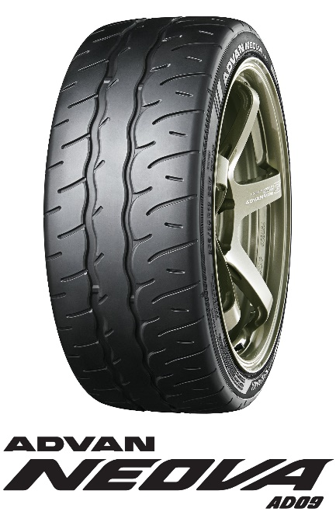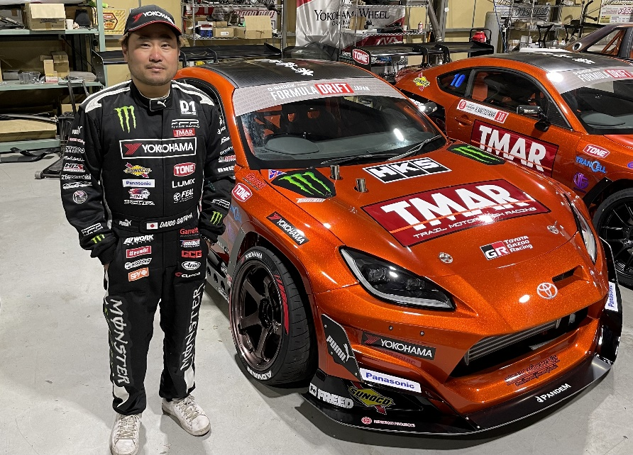
Daigo Saito and Machine for FDJ, TMAR GR86

