25th May 2022

YOKOHAMA supporting 3 Walkenhorst Motorsport cars competing in the 2022 Nürburgring 24-Hour Race

YOKOHAMA is pleased to announce that it will be supplying its ADVAN racing tyres for three BMW M4 GT3 cars entered by the BMW customer racing team Walkenhorst Motorsport in the 50th Nürburgring 24-Hour Race (the ADAC TotalEnergies 24h Nürburgring), to be held in Germany on 26th – 29th May 2022. All three cars will be competing in the top-level SP9 class. YOKOHAMA will supply the cars with ADVAN A005 tyres for dry conditions and ADVAN A006 tyres for wet conditions.

As part of a partnership agreement with Walkenhorst Motorsport, YOKOHAMA has been supplying tyres for the team’s cars participating in the Nürburgring Endurance Series (NLS) as well as the Nürburgring 24-Hour Race. The drivers racing on ADVAN tyres at this year’s Nürburgring 24-Hour Race will include Christian Krognes, winner of the sixth race in last year’s NLS and third-place finisher in this year’s second race, and former BMW Works driver Jörg Müller, well-known for his excellent performances in FIA World Touring Car Championship (WTCC) and SUPER GT races. The #101 car to be driven by Christian Krognes and his fellow drivers will prominently display the YOKOHAMA logo on the side, roof, and rear wing of its strikingly coloured body.

Under YOKOHAMA’s three-year (2021–2023) medium-term management plan, Yokohama Transformation 2023 (YX2023), the consumer tyre business aims to maximize the sales ratios of high-value-added YOKOHAMA tyres, namely the global flagship ADVAN brand, the GEOLANDAR brand of tyres for SUVs and pickup trucks, and various winter tyres.YX2023 also positions participation in motorsports activities as crucial to the company’s effort to develop new tyre technologies that will further strengthen the ADVAN and GEOLANDAR brands. YOKOHAMA therefore is again participating in a wide variety of motorsports events in Japan and around the globe, from top-category to grassroots events.
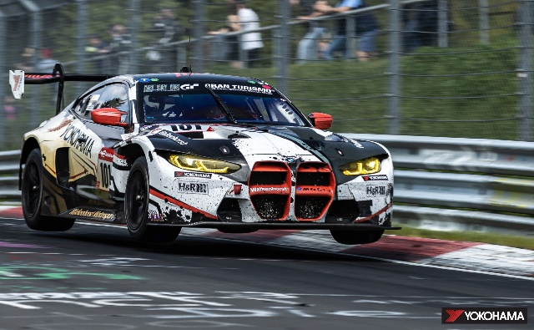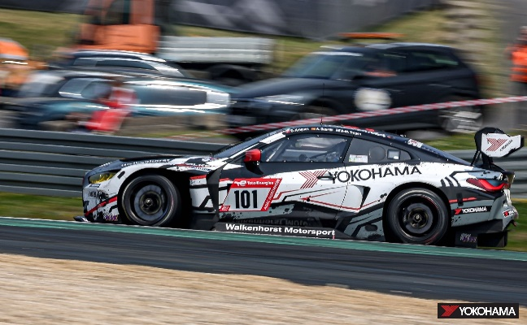
The #101 BMW M4 GT3 to be driven by Christian Krognes and his fellow drivers
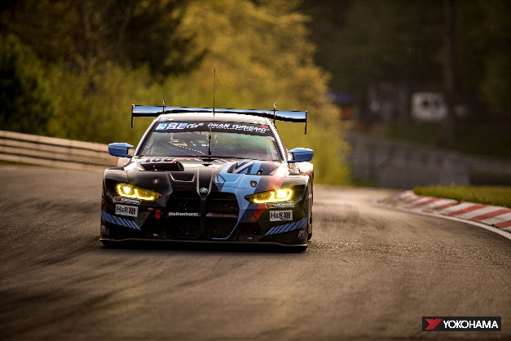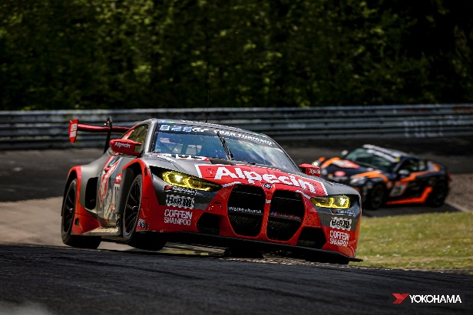
The #100 BMW M4 GT3 to be driven by Henry The #102 BMW M4 GT3 to be driven by Jörg Müller
Walkenhorst and his fellow drivers and his fellow drivers

