5th April 2021

YOKOHAMA supported teams finish one-two in the top JN-1 class at Round 2 of the Japanese Rally Championship

YOKOHAMA is pleased to announce that machines equipped with ADVAN tyres finished first and second in the top JN-1 class at the Shinshiro Rally 2021, Round 2 of this year’s Japanese Rally Championship series, held during 19th – 21st March.

As Round 1 originally scheduled to be held in February was cancelled, the Shinshiro Rally was effectively the first round of this year’s series. Competing in heavy rain, the Toshihiro Arai/Naoya Tanaka team driving the FUJISUBARU AMS WRX STI finished ahead of the pack, followed by the Hiroki Arai/Noritaka Kosaka team in their ADVAN KYB AMS WRX. The result is a great start toward the ultimate goal of capturing the series top JN-1 class championship. Teams drove to the finish on “ADVAN A08B”and “ADVAN A052” street sport tyres.

The consumer tyre business in YOKOHAMA’s new three-year (2021–2023) medium-term management plan, Yokohama Transformation 2023 (YX2023), aims to maximize the sales ratios of high-value-added YOKOHAMA tyres, namely the global flagship ADVAN brand, the GEOLANDAR brand of tyres for SUVs and pickup trucks, and various winter tyres. YX2023 positions participation in motorsports activities as crucial to the company’s effort to develop new tyre technologies that will further strengthen the ADVAN and GEOLANDAR brands. YOKOHAMA therefore is again participating in a wide variety of motorsports events in Japan and around the globe, from top-category to grassroots events.

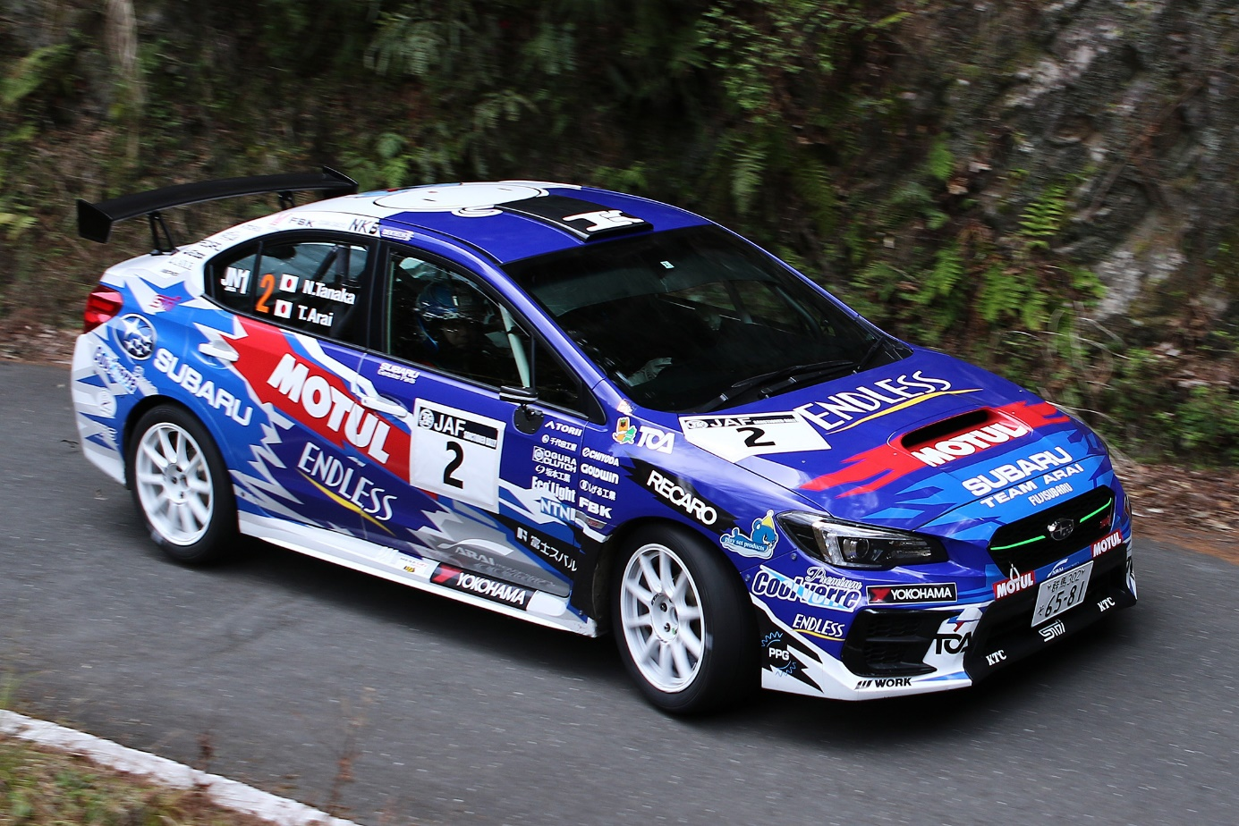
The Shinshiro Rally 2021 victorious machine driven by Toshihiro Arai and Naoya Tanaka

