17th October 2022

YOKOHAMA supplying tyres to drivers participating in this year’s AXCR with support from TOYOTA GAZOO Racing Indonesia and TCD Asia Pacific Indonesia

YOKOHAMA announced today that it will be supplying tyres to Takuma Aoki and Ikuo Hanawa in the upcoming Asia Cross Country Rally 2022 (hereafter, AXCR), Asia’s largest cross-country rally, which will be held from 21st to 26th November 2022. The supplied tyres will be GEOLANDAR M/T G003 mud-terrain tyres for SUVs and pick-up trucks. Both drivers are being supported by TOYOTA GAZOO Racing Indonesia and TCD Asia Pacific Indonesia and will be racing in Toyota Fortuner* SUVs for the FORTUNER GEOLANDAR Takuma-GP team.
*A popular frame-type SUV sold mostly in Asia

The AXCR is an FIA (Federation Internationale de l’Automobile) officially sanctioned rally event, similar to the Dakar Rally. Past AXCR races have taken competitors across diverse terrain, ranging from mountains, jungles, beaches, plantation lands, and race car circuits in many Asian countries. This year’s AXCR will be the first in three years as the Covid-19 pandemic cancelled the event in 2020 and 2021. The rally will start on 21st November in Thailand and take drivers across a 1,700km course to the finish line in Cambodia five days later on 26th November.

Takuma Aoki is a former motorcycle racer. Paralyzed the waist down from in a crash during a motorcycle race practice run, Takuma took up the challenge of racing four-wheel vehicles and has since been active on the overseas rally circuit. He has participated in AXCR events with YOKOHAMA’s support 13 times since 2007. He finished third in 2011 in a car running on GEOLANDAR tyres. More recent top 10 finishes include ninth place in 2016 and a sixth place finish in 2017.
Ikuo Hanawa is a world-class off-road racer representing Japan. Participating with support from YOKOHAMA, Ikuo captured overall championships in the 2016 and 2018 SMOKIN WHEEL’S OFFROAD GRANDPRIX held in the United States. At the Mint 400, the oldest off-road race in America, Ikuo followed up his third-place Class 7 finish in 2020 with a second-place finish in March this year.

GEOLANDAR M/T G003 tyres deliver superior performance on the full range of off-road surfaces over an exceptionally long lifespan. In addition, the tyre features a sturdy and aggressive design that enhances the off-road driving sensation. YOKOHAMA’s GEOLANDAR tyres have demonstrated their superior off-road performance in many races over the years, including a one-two finish in the 4800 class at the 2021 King Shocks Area BFE Beatdown and a first-place finish in the Trick Truck class of the 2021 King Shocks Laughlin Desert Classic - both races held in the United States.

Under YOKOHAMA’s three-year (2021–2023) medium-term management plan, Yokohama Transformation 2023 (YX2023), the consumer tyre business aims to maximize the sales ratios of high-value-added YOKOHAMA tyres, namely the global flagship ADVAN brand, the GEOLANDAR brand of tyres for SUVs and pick-up trucks, and various winter tyres. YX2023 also positions participation in motorsports activities as crucial to the company’s effort to develop new tyre technologies that will further strengthen the ADVAN and GEOLANDAR brands. YOKOHAMA therefore is again participating in a wide variety of motorsports events in Japan and around the globe, from top-category to grassroots events.

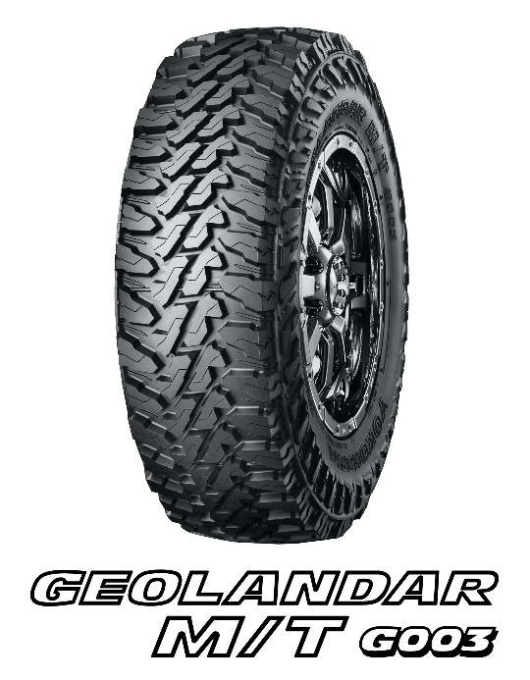

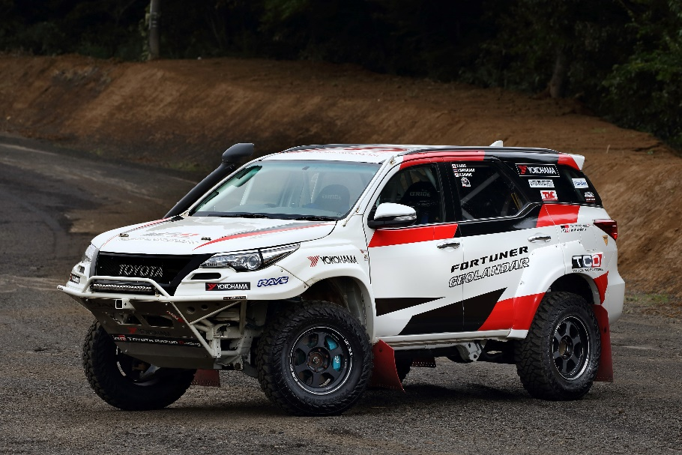
Toyota Fortuner Car #1 to be driven by Takuma Aoki

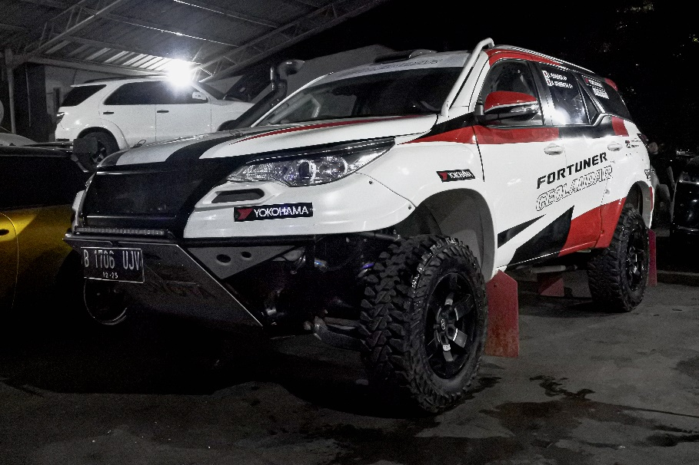
Toyota Fortuner Car #2 to be driven by Ikuo Hanawa

