25th April 2024
YOKOHAMA supplying its ADVAN Sport V107 for leading German automotive manufacturer’s premium SAVs
YOKOHAMA announced today that it is supplying its “ADVAN Sport V107” tyres to the BMW Group as an original equipment (OE) on the BMW X7 Sports Activity Vehicle (SAV) and the BMW XM Plug-in-Hybrid SAV currently available from the German automaker. Three types of size combinations are supplied: HL275/35R23 108Y (front) and HL315/30R23 111Y (rear) common to the BMW X7 and BMW XM, as well as 275/45R21 110Y (front) and 315/40R21 115Y (rear), and 275/40R22 107Y (front) and 315/35R22 111Y (rear) for the BMW XM. The 22-inch size tyres for the BMW XM are supplied with performance specifications and high-performance specifications.
The “ADVAN Sport V107” is an ultra-high performance tyre in YOKOHAMA’s global flagship ADVAN brand. The tyres being supplied to the BMW Group were jointly developed with the automaker. While employing a specialized tread pattern to combine their pass-by acceleration noise performance with steering stability and using a specially-tuned compound, YOKOHAMA’s original “Mound Profile” technology ensures more uniform surface contact that further contributes to their superior dry performance and wear resistance. Their profile has also been optimized while adopting a structure with a specialized design to support the load of large SUVs, and a sidewall design with reduced surface unevenness to improve their aerodynamic performance. BMW Group cars use OE tyres from a select group of tyre manufacturers, and the sidewall of all selected tyres bear BMW’s star mark symbol of approval, which indicates the German car manufacturer´s recognition of the tyre manufacturers’ technical capabilities, quality and reliability.
The HL275/35R23 108Y and HL315/30R23 111Y sizes for the BMW X7 and BMW XM are HLC tyres* that can accommodate new-generation vehicles with heavy vehicle weights, such as large SUVs and EVs which are loaded with large-capacity batteries, and bear an “HL” symbol before the tyre size. These sizes use new specialized profiles that allow them to withstand high loads while achieving a balance with other aspects of performance.
The high-performance specifications for the 22-inch size intended for the BMW XM include the use of a high-grip compound, and also adopt a specially-tuned structure to balance both wear resistance and high-speed durability when driving on the race track. The tyre sidewalls bear a “I” before the star mark to distinguish them from tyres with performance specifications having the same size.
Under YOKOHAMA’s three-year (2024–2026) medium-term management plan, Yokohama Transformation 2026 (YX2026), the consumer tyre business aims to maximize the sales ratios of high-value-added tyres. One of the key initiatives under this strategy is promoting the global flagship ADVAN brand tyres and the GEOLANDAR brand tyres for SUVs and pick-up trucks as original equipment for new cars.
*Tyres which have load capacities even higher than XL (extra load) tyres whose air pressure and load capacity are set higher than the standard specifications.
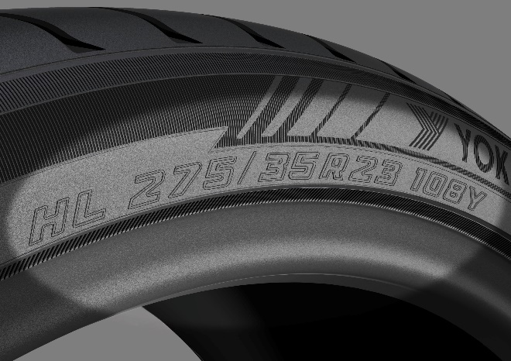
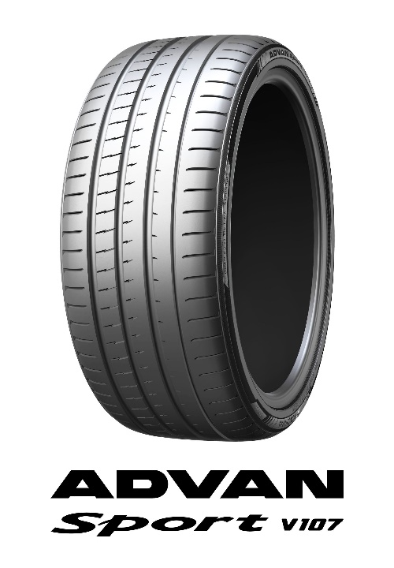
“ADVAN Sport V107” HL275/35R23 108Y

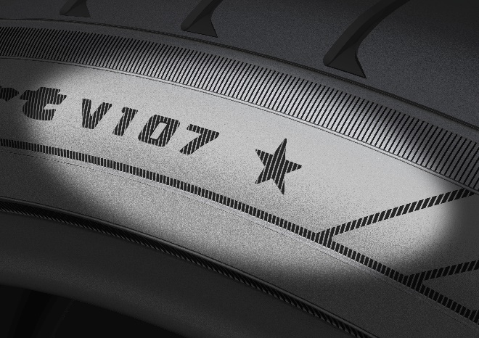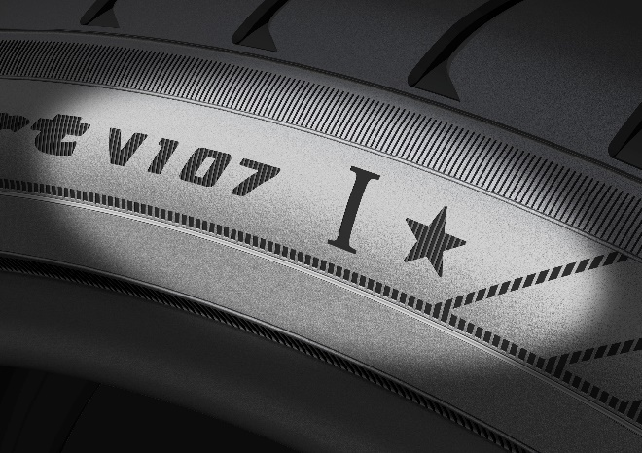
★ mark (star mark) to indicate approval of technical capabilities, quality, and reliability
*The photo shows the high-performance specification tyre for the 22-inch size intended for the BMW XM

★ mark (star mark) to indicate approval of technical capabilities, quality, and reliability

