18th August 2022

YOKOHAMA’s new OHT plant in India starts production

YOKOHAMA announced today the start of production at its Visakhapatnam Plant in India. The new plant was built to expand the production capacity of Yokohama Off-Highway Tyres (YOHT), a Yokohama Rubber Group company engaged in the manufacturing and sale of off-highway tyres (OHT), such as those used on agricultural and other equipment. The new plant was originally scheduled to begin production in the first quarter of 2023. The earlier than planned start-up will enable YOHT to respond more quickly to expanding global demand for OHT tyres. The plant’s opening ceremony held on 16th August 2022 was attended by Mr. Jagan Mohan Reddy, the chief minister of Andhra Pradesh, the Indian state where the plant is located, Mr. Masayuki Taga, Consul General of Japan in Chennai, and Nitin Mantri, a member of the board and managing officer of the Yokohama Rubber and the head of the Group’s OHT division.

In his greeting at the opening ceremony, Nitin Mantri said, “We are very excited with this best-in-class facility that will set a new benchmark for quality and productivity in the OHT segment. With our increased capacity we will reduce our lead times to better serve our global customer base”.

YOHT also has two other tyre plants in India - the Dahej Plant in the state of Gujarat and the Tirunelveli Plant in Tamil Nadu. The plants produce three of the Group’s core OHT brands - the ALLIANCE, GALAXY and PRIMEX brands - which are used on agricultural, construction, industrial and forestry machinery. YOHT sales have been expanding faster than the overall OHT market. To meet the demand for its products, YOKOHAMA began the construction of the Visakhapatnam Plant in the third quarter of 2020 to supplement a 1.6x expansion of production capacity at the Dahej Plant. In its initial production stage, the Visakhapatnam Plant will have a daily capacity of 69 tons (rubber weight). The plant’s daily capacity will be increased to 132 tons in the second stage planned to start in the first quarter of 2024. Further expansion of the plant’s capacity is under consideration.

YOKOHAMA’s medium-term management plan, Yokohama Transformation 2023 (YX2023) covering FY2021–FY2023, includes a commercial tyre strategy that positions the Group’s OHT business as a future growth driver. The Group plans to expand its OHT business by capitalizing on the strength of a multi-brand line-up that includes YOKOHAMA, ALLIANCE, GALAXY, PRIMEX, and AICHI brand OHTs to develop new markets and meet diverse customer needs. At the same time, the Group is increasing its OHT production capacity in an effort to further accelerate the strengthening of its competitiveness in the global OHT market.

Outline of Visakhapatnam Plant
Company Name | ATC Tires AP Pvt. Ltd.
Location | Atchutapuram Industrial Park, Visakhapatnam, Andhra Pradesh, India
Business | Manufacture and sale of off-highway tyres
Production Items | ALLIANCE, GALAXY and PRIMEX brand tyres
Daily Production Capacity | 132 tons (rubber weight) *including 2nd stage expansion; an increase of 9 tons from the initial plan
Site Area | Approximately 390,000m2

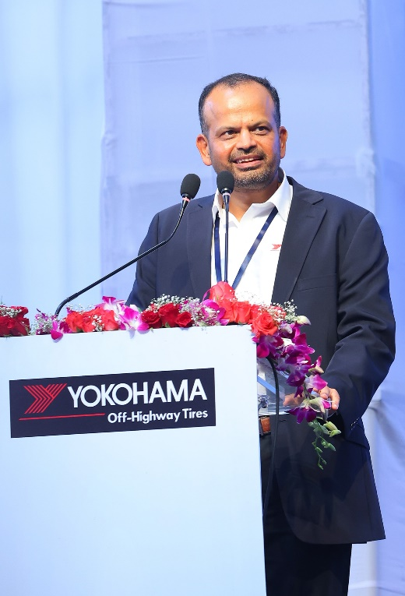
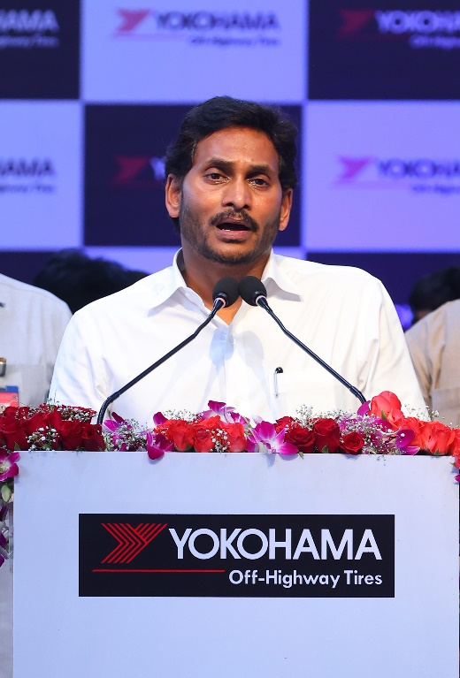
Mr. Jagan Mohan Reddy (Chief Minister of Nitin Mantri (Member of the Board and Managing Officer, Andhra Pradesh) speaking at the opening Head of OHT Division) speaking at the opening ceremony
ceremony

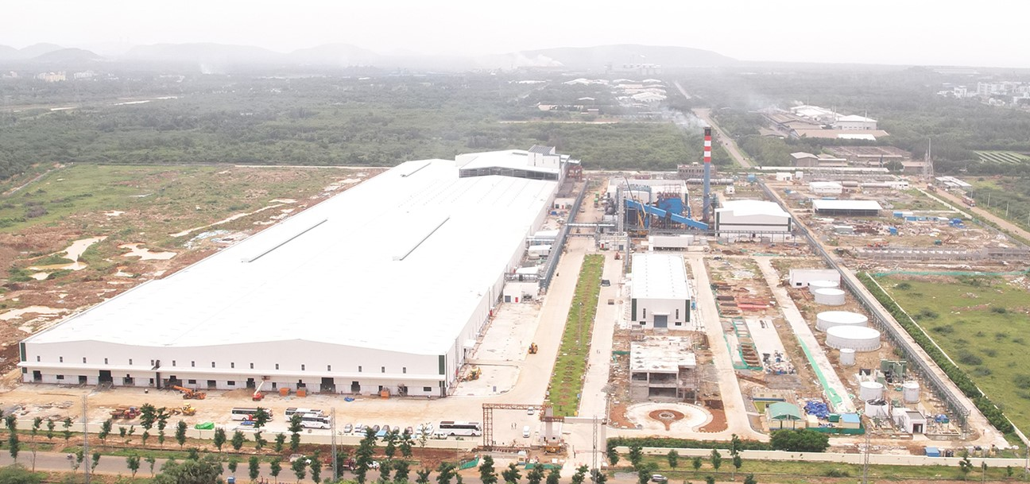
The Visakhapatnam Plant

