31st January 2022

YOKOHAMA’s natural rubber processing subsidiary supporting Thai villages affected by recent flooding

YOKOHAMA announced today that in December 2021 its natural rubber processing subsidiary in Thailand, Y.T. Rubber Co., Ltd. (YTRC), provided needed food packages to Thai villagers affected by floods caused by heavy rains in the country’s Surat Thani Province, where YTRC is located. YTRC provided packages consisting of 5kg of rice and twelve 500ml PET bottles to each of 383 households in two neighbouring villages. The packages were distributed while taking necessary measures to prevent possible COVID-19 infections. The recent flooding affected more households than the flooding that occurred in 2020, and the village heads expressed their appreciation of YTRC’s efforts, noting that the company’s donations after both disasters are examples of its constant consideration for village residents.

YTRC has regularly engaged in activities aimed at contributing to its local community and building relationships of trust. In addition to its disaster relief efforts, the company has sponsored various local events and provided seedlings in support of local tree-planting activities. YTRC also supports the local community by providing the fruit from palm trees and the fish from a pond within the company grounds, thus contributing a source of food and income for local residents. Under YOKOHAMA's "Procurement Policy for Sustainable Natural Rubber," YTRC also is cooperating with the Rubber Authority of Thailand to provide economic support for Thai natural rubber farmers and to improve traceability to ensure transparency and soundness of the supply chain.

Under its medium-term management plan for fiscal years 2021–2023, Yokohama Transformation 2023 (YX2023), YOKOHAMA is implementing ESG initiatives based on the concept of “Caring for the Future.” Through these ESG initiatives, YOKOHAMA hopes its business activities will contribute to the resolution of social issues.

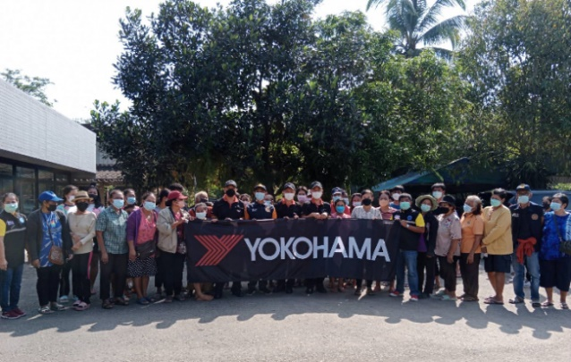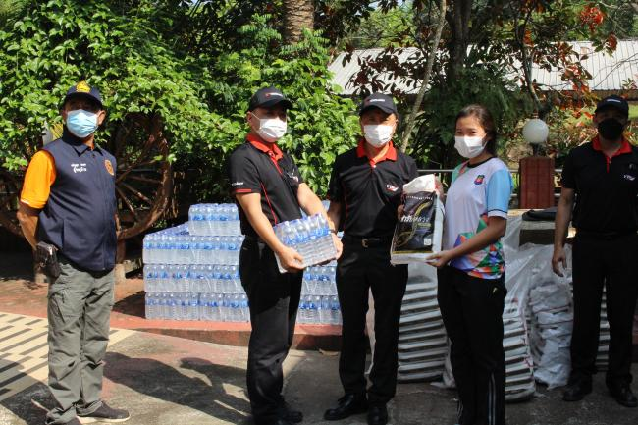
YOKOHAMA employees who distributed relief packages YTRC employees distributing relief packages to local
with Surat Thani residents villagers

