21st September 2021

YOKOHAMA’s “ADVAN Sport V105” selected as the tyre on new Volkswagen concept SUV

YOKOHAMA is pleased to announce that its “ADVAN Sport V105” has been selected by Volkswagen of America as the tyre on its Atlas Cross Sport GT Concept, unveiled in July. The concept model is outfitted with 285/35ZR22 106Y size of the ADVAN Sport V105 tyres.

Based on Volkswagen’s Atlas Cross Sport for the North American market, the Atlas Cross Sport GT Concept is a high-performance model with a 2.0-liter TSI® engine capable of generating more than 300 horsepower. The concept model has been redesigned from the current production model’s 5-seat interior to a 4-seat configuration, and it features a striking "Kingfisher Blue” body colour.

The “ADVAN Sport V105” is a high-performance tyre developed by YOKOHAMA primarily for use on high-power premium automobiles. The “ADVAN Sport V105” is designed to contribute to the vehicle’s excellent driving performance while providing superior comfort and safety, a balanced performance well-suited for a high-performance model bearing the GT initials.

Under YOKOHAMA’s three-year (2021–2023) medium-term management plan, Yokohama Transformation 2023 (YX2023), the consumer tyre business aims to maximize the sales ratios of high-value-added YOKOHAMA tyres, namely the global flagship ADVAN brand, the GEOLANDAR brand of tyres for SUVs and pic-kup trucks, and various winter tyres.

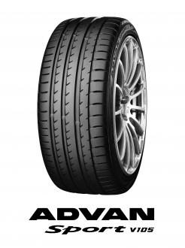
The “ADVAN Sport V105”; tyre shown in photo differs from those installed on the Atlas Cross Sport GT Concept

