26th April 2024
YOKOHAMA's YOKOHAMA RY53 tyres coming factory-equipped on Toyota's new Hilux Champ
YOKOHAMA announced today that it is supplying its YOKOHAMA RY53 tyres as original equipment (OE) to Toyota Motor Corporation for use on the car manufacturer´s new pick-up truck, the Hilux Champ, sales of which were launched in Asia in November 2023. The OE tyre size is the 195R14C 106/104S.
The YOKOHAMA RY53 is a tyre specifically for light trucks that has excellent wear resistance and fuel efficiency. To meet the performance of the new Hilux Champ, the YOKOHAMA RY53 tyres supplied as OE have a specially tuned profile to achieve high steering stability and comfort.
YOKOHAMA is strengthening the supply of its tyres as OE and expanding the product lineup for pick-up trucks, which are becoming increasingly popular in North America in particular. In 2022, the company started supplying its GEOLANDAR X-CV tyres as OE for the Toyota Tundra, a full-size pick-up truck. In 2023, it launched the GEOLANDAR A/T XD, tyres for full-size pick-up trucks and other commercial vehicles.
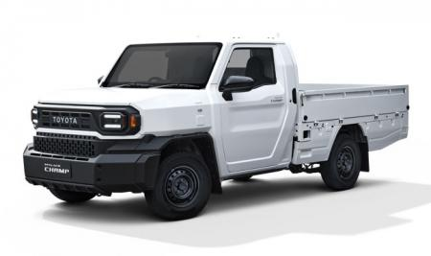
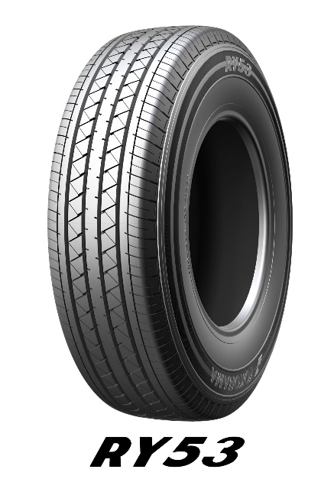
The new Hilux Champ *The above photo is used with the permission of Toyota Motor Corporation. Reprint or other usage of this image without prior permission from Toyota Motor is strictly prohibited.

