8th September 2023

YOKOHAMA’s Thai natural rubber processing company obtains CoC certification from FSC

YOKOHAMA announced today that Y.T. Rubber Co., Ltd. (hereafter, YTRC), a Thai natural rubber processing company of YOKOHAMA, obtained the Chain of Custody (CoC) certification in July 2023. The CoC certification is provided by FSC®*, an international forest certification organization, for the management of processing and distribution.
*FSC®: Forest Stewardship Council®, an international non-profit organization established in 1994 to promote responsible forest management worldwide.

The FSC® certification is a mechanism to provide consumers with visibility toward products using forest materials from well-managed forests and other low-risk forest products consistent with environmental, social, and economic benefits. The CoC certification certifies the processing and distribution of products until certified materials harvested from FSC®-certified forests reach consumers. This certification guarantees that all the processes up to the completion of products are controlled to prevent contamination by ineligible raw materials when YTRC manufactures natural rubber products using rubber harvested from FSC®-certified forests.

A founding member of the Global Platform for Sustainable Natural Rubber (GPSNR), YOKOHAMA revised its “Procurement Policy for Sustainable Natural Rubber” in September 2021 and is strengthening its collaboration with GPSNR activities. The acquisition of this CoC certification reflects the principles of “Improving traceability” and ”Environmental initiatives” set forth in the Procurement Policy. YOKOHAMA will continue to implement and announce initiatives in line with the action guidelines stipulated in this policy. YOKOHAMA also is endeavouring to achieve the Sustainable Development Goals (SDGs) adopted by the United Nations. As part of these efforts, the Yokohama Rubber Group is promoting the procurement of sustainable raw materials, including natural rubber.

Yokohama Transformation 2023 (YX2023), YOKOHAMA’s medium-term management plan for fiscal years 2021–2023, includes sustainability initiatives that are based on the concept of “Caring for the Future.” YOKOHAMA believes that conducting business activities aligned with its sustainability initiatives will help resolve social issues and lead to the continued increase of its corporate value.
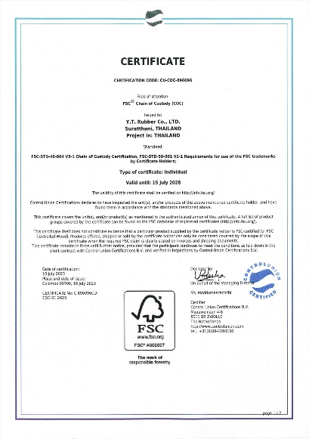

CoC certificate YTRC received from FSC®

