12th January 2022

YOKOHAMA’s New Flagship Tyre ADVAN Sport V107 Approved for the BRABUS 700, 800 and 900 Off Roader

YOKOHAMA has announced that the company's global-flagship-brand tyre ADVAN Sport V107 has been approved by BRABUS GmbH of Germany for its BRABUS 700/800/900 Off Roader based on the Mercedes-AMG G63. The tyres to be supplied are ADVAN Sport V107 with following tyre size: 305/35R23 111Y XL.

BRABUS approved this size of ADVAN Sport V107 with a view to achieve a perfect balance of driving performance combined with superior comfort and safety characteristics, such as dry/wet performance and steering stability.

BRABUS is one of the world's premier car tuners and manufacturers, specialising in Mercedes-
Benz, and has been in a technological partnership with YOKOHAMA for the development of tyres since 2005.

YOKOHAMA has been actively expanding worldwide its flagship brand ADVAN symbolising the company's global reach and high-performance attributes. ADVAN tyres, whose performance and quality are highly respected, have been adopted not only as original equipment for world leading high-performance cars, but also in the competitive motorsports field for many years.

Under YOKOHAMA’s three-year (2021–2023) medium-term management plan, Yokohama Transformation 2023 (YX2023), the consumer tyre business aims to maximize the sales ratios of high-value-added YOKOHAMA tyres, namely the global flagship ADVAN brand, the GEOLANDAR brand of tyres for SUVs and pick-up trucks, and various winter tyres. In 2022, the Company plans to strengthen sales of ADVAN brand summer tyres by launching the ADVAN Sport V107, as well as its new high-performance street sports tyre, the ADVAN NEOVA AD09.

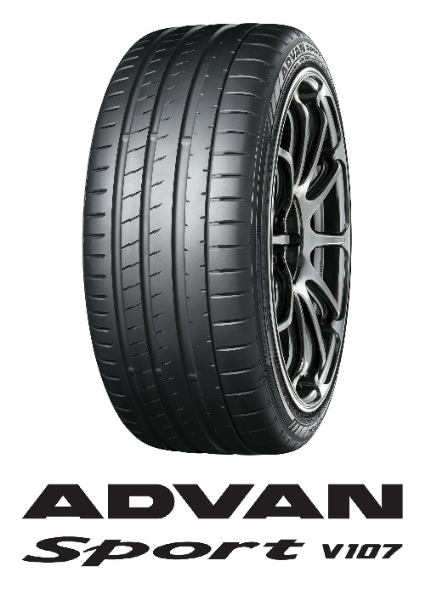
BRABUS 800 "BLACK OPS" - LIMITED EDITION "1 OF 10"
*The above photo is used with the permission of BRABUS
GmbH. Reprint or other usage of this image without prior
permission from BRABUS GmbH is strictly prohibited.
Tyre shown in photo differs in size from those installed on BRABUS 700/800/900 Off Roader

