4th February 2022

YOKOHAMA’s GEOLANDAR X-CV is now coming factory-equipped on Toyota’s Lexus LX

YOKOHAMA announced today that it began supplying its GEOLANDAR X-CV to Toyota Motor Corporation this January for use as original equipment (OE) tyres on Toyota’s new Lexus LX SUV. The Lexus LX is being fitted with 265/55R20 and 265/50R22 size tyres.

The GEOLANDAR X-CV represents a new dimension in highway terrain tyres developed for high-performance crossover SUVs, which have increasingly focused on high-speed performance and manoeuvrability in recent years. GEOLANDAR is YOKOHAMA’s global brand of tyres for SUVs and pick-up trucks, and the Company is accelerating the expansion of the brand’s line-up to meet increasingly diversified needs in the SUV market.

Based on the replacement market tire of the same name, the GEOLANDAR X-CV being delivered to Toyota has been finely tuned to meet the high-performance standards of the new Lexus LX. In addition to significantly reducing rolling resistance, the tyre provides outstanding steering stability and comfort and is highly reliable even in the harshest environments. The tyre’s sophisticated and stylish side design makes it particularly suitable for use on luxury premium SUVs, like Toyota’s Lexus LX.

Under YOKOHAMA's current medium-term management plan, Yokohama Transformation 2023 (YX2023), the consumer tyre business aims to maximize the sales ratios of high-value-added YOKOHAMA tyres, namely the global flagship ADVAN brand, the GEOLANDAR brand of tyres for SUVs and pick-up trucks, and various winter tyres. One of the key initiatives being implemented under this strategy is the expansion of ADVAN and GEOLANDAR tyres as original equipment on new cars.

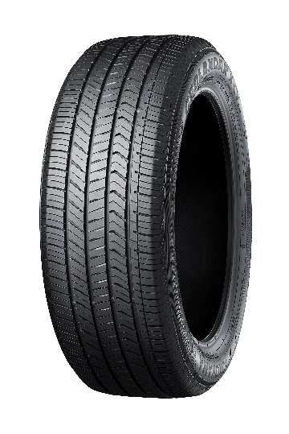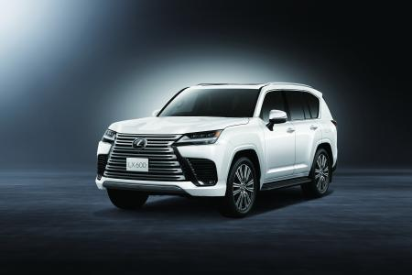

The new Lexus LX *This photo is used with the permission of Toyota Motor Corporation. Reprint or other usage of this image without prior permission from Toyota Motor is strictly prohibited.
GEOLANDAR X-CV *Tyre shown in photo differs in size from those installed on the new Lexus LX.

