18th October 2022

YOKOHAMA’s GEOLANDAR X-CV coming factory-equipped on Toyota’s new Tundra and Sequoia

YOKOHAMA announced today that it has begun supplying its GEOLANDAR X-CV tyres as original equipment (OE) for Toyota Motor Corporation’s new Tundra, the automaker’s full-size pick-up truck, and its new Sequoia full-size SUV. Both models went on sale in the North America and Latin America markets. YOKOHAMA is supplying three tyre sizes for the Tundra - 265/60R20 112H, 245/75R18 112T, and 265/70R18 116T - and two for the Sequoia - 265/60R20 112H and 265/70R18 116T.

The GEOLANDAR X-CV tyres being supplied for the Tundra and Sequoia feature a specially tuned tread pattern and a newly developed compound that fulfil both models’ need for superior steering stability and the excellent braking performance on both dry and wet roads. The tread pattern and new compound also achieve the normally difficult combination of outstanding wear resistance and greatly reduced rolling resistance.

The GEOLANDAR X-CV represents a new dimension in highway terrain tyres, which focus on high-speed performance and manoeuvrability. GEOLANDAR is YOKOHAMA’s global brand of tyres for SUVs and pick-up trucks, and the Company is accelerating the expansion of the brand’s line-up to meet increasingly diversified needs in the market.

Under YOKOHAMA’s current medium-term management plan, Yokohama Transformation 2023 (YX2023), the consumer tyre business aims to maximize the sales ratios of high -value- added YOKOHAMA tyres, namely the global flagship ADVAN brand, the GEOLANDAR brand of tyres for SUVs and pickup trucks, and various winter tyres. One of the key initiatives under this strategy is the expansion of ADVAN and GEOLANDAR tyres as original equipment on new cars.

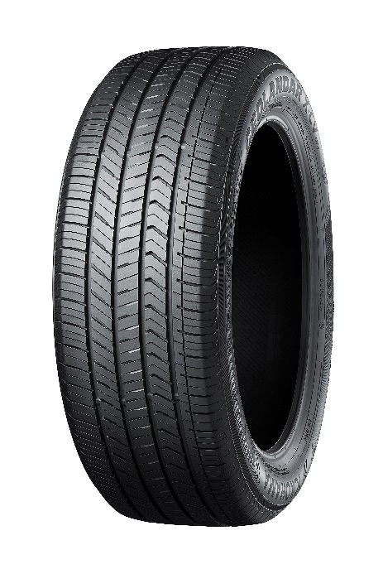
GEOLANDAR X-CV
*Tyre shown in photo differs in size from those being
supplied for Toyota’s new Tundra and Sequoia.

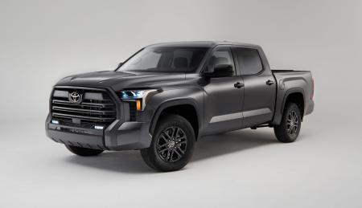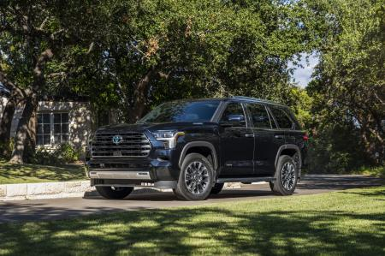

Toyota’s new Tundra (left) and Sequoia (right)
*The above photos are used with the permission of Toyota Motor North America.
Reprint or other usage of these images is strictly prohibit

