12th March 2024
YOKOHAMA’s GEOLANDAR A/T G94 tyres coming factory-equipped on Mitsubishi Motors’ new Triton
YOKOHAMA announced today that it is supplying its GEOLANDAR A/T G94 to be used as original equipment (OE) tyres on the new Triton pickup truck, which was launched by Mitsubishi Motors Corporation (hereafter, Mitsubishi Motors) in February 2024 in Japan. The Triton has been introduced to the Japanese market for the first time in about 12 years and is being fitted with 265/60R18 110H size tyres. The new Triton was launched in Thailand in July 2023, in the Philippines in January 2024, and in Australia and New Zealand in March 2024, and will be successively launched in approximately 100 countries around the world.
The GEOLANDAR A/T G94 is an all-terrain tyre for SUVs and pick-up trucks that offers excellent fuel efficiency, comfort, and safety performance, as well as utility performance on a variety of road surfaces. The durability of the newly fitted tyres was improved by enhancing the rigidity of the belt section to handle the harsh operating environments that pick-up trucks often face. The compound and profile were specially tuned to provide a high level of balance between otherwise contradictory performance factors, such as improved control stability and rolling resistance while achieving superior quietness.
The Triton is a Mitsubishi Motors’ global strategic vehicle exported to approximately 150 countries around the world. Now in its sixth generation, the all-new Triton is fully redesigned for the first time in nine years. Based on the product concept of “Power for Adventure,” all elements of the Triton have been completely reimagined, from the interior and exterior design to the chassis, ladder frame, and engine. Safety, comfort, and environmental performance were also improved, in addition to durability and road performance.
Under YOKOHAMA’s three-year (2024–2026) medium-term management plan, Yokohama Transformation 2026 (YX2026), the consumer tyre business aims to maximize the sales ratios of high-value-added tyres. One of the key initiatives under this strategy is promoting the global flagship ADVAN brand tyres and the GEOLANDAR brand tyres for SUVs and pick-up trucks as original equipment for new cars.

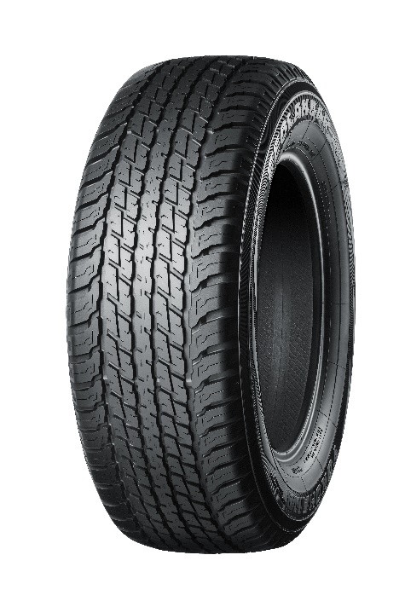
GEOLANDAR A/T G94 *The tyre shown in the photo differs in size from those installed on the new Triton.

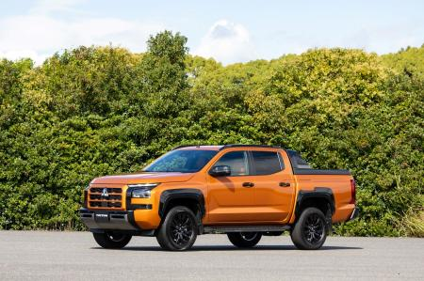
The all-new Triton *This photo is used with the permission of Mitsubishi Motors Corporation. Reprint or other usage of this image without prior permission from Mitsubishi Motors Corporation is strictly prohibited.

