16th April 2024
YOKOHAMA’s GEOLANDAR A/T G015 tyres coming factory-equipped on Toyota’s CROWN CROSSOVER RS “LANDSCAPE”
YOKOHAMA announced today that it is supplying its GEOLANDAR A/T G015 tyres as original equipment (OE) to Toyota Motor Corporation for use on the car manufacturer´s new CROWN CROSSOVER RS “LANDSCAPE”, a special edition of CROWN CROSSOVER. The new vehicle was launched in April 2024 in Japan. The tyre size is 245/60R18 109H.
The GEOLANDAR A/T G015 is an all-terrain tyre for SUVs that delivers superb drivability and durability in off-road conditions and a comfortable, quiet ride on city streets. The tyre shoulder's aggressive design achieves the powerful image befitting SUVs.
GEOLANDAR is YOKOHAMA’s global brand of tyres for SUVs and pick-up trucks, and the Company is accelerating the expansion of the brand’s line-up to meet increasingly diversified needs in the SUV market.
Under YOKOHAMA’s three-year (2024–2026) medium-term management plan, Yokohama Transformation 2026 (YX2026), the consumer tyre business aims to maximize the sales ratios of high-value-added tyres. One of the key initiatives under this strategy is promoting the global flagship ADVAN brand tyres and the GEOLANDAR brand tyres for SUVs and pick-up trucks as original equipment for new cars.
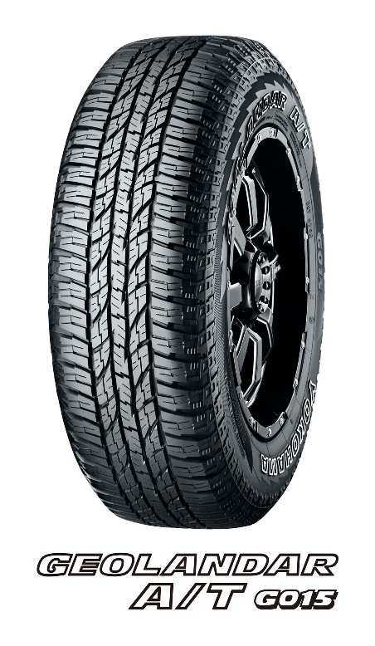

GEOLANDAR A/T G015
*The tyre shown in the photo differs in size from those installed on the CROWN CROSSOVER RS “LANDSCAPE”. (wheel shown is not standard equipment)

The CROWN CROSSOVER RS “LANDSCAPE” *The above photo is used with the permission of Toyota Motor Corporation. Reprint or other usage of this image without prior permission from Toyota Motor is strictly prohibited.

