25th March 2024

YOKOHAMA’s BluEarth-XT AE61 tyres coming factory-equipped on Toyota’s new YARIS CROSS

YOKOHAMA announced today that it is supplying its BluEarth-XT AE61 tyres as original equipment (OE) to Toyota Motor Corporation for use on the car manufacturer´s new compact SUV, YARIS CROSS, which was launched in Thailand in October 2023. The YARIS CROSS is being fitted with 215/60R17 96H and 215/55R18 95V size tyres.
*The new YARIS CROSS is not available in Japan.

The BluEarth-XT AE61 is a summer tyre developed specifically for use on crossover urban SUVs. The tyre contributes to high steering stability worthy of YARIS CROSS thanks to its specially tuned profile, in addition to the advantages of its lightweight design and further reduced rolling resistance. The performance of the tyre was achieved using a proprietary system to predict the values of key tyre characteristics based on YOKOHAMA’s proprietary HAICoLab*, an AI-based development framework that aims to foster new discoveries and digital innovation by merging human inspiration and creativity with AI’s enormous data processing capability. The innovative technologies applied in development of the tyres are based on new knowledge obtained by collecting actual data and virtual data generated by simulations and then using AI’s predict, analyse and search functions.
* An acronym for “Humans and AI Collaborate” for digital innovation

YOKOHAMA is aggressively developing tyres employing its leading-edge BluEarth tyre technology, and many of these tyres are now coming factory-equipped on gasoline-powered vehicles, hybrid cars and EVs such as a wide variety of new car models, including the latest-model sedans, SUVs, sports cars, and compact cars.

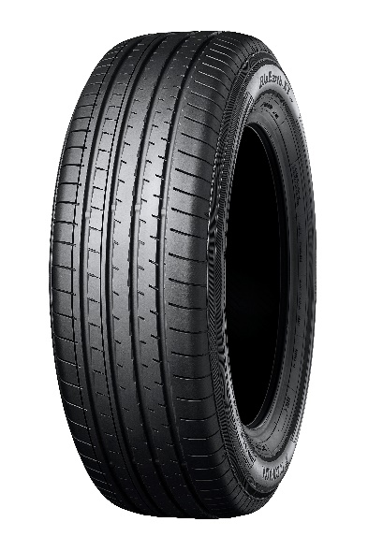
New YARIS CROSS *The above photo is used with the permission of Toyota Motor Corporation. Reprint or other usage of this image without prior permission from Toyota Motor is strictly prohibited.

BluEarth-XT AE61
*Tyre shown in photo differs in size from those installed on the YARIS CROSS

HAICoLab conceptual diagram

