18th January 2022

YOKOHAMA’s BluEarth-XT AE61 coming factory-equipped on Toyota’s Lexus NX

YOKOHAMA announced today that since November 2021 it has been supplying its BluEarth-XT AE61 and BluEarth-XT AE61 Z.P.S^{*1} tyres to Toyota Motor Corporation for use as original equipment (OE) tyres on an all-new Lexus NX, the first PHEV. The PHEV model is being fitted with 235/60R18 103H size tyres.

BluEarth is a YOKOHAMA global tyre brand based on the concept of being “environmentally, human, and socially friendly”. The BluEarth-XT AE61 incorporates the basic design and material technologies of YOKOHAMA’s BluEarth brand tyres. The tyre’s superior driving, comfort and environmental performance make it an outstanding grand touring tyre. In addition, a newly developed tread pattern enhances the tyre’s wet performance, wear resistance, and stability, contributing to the all-new NX’s high-quality ride.

The BluEarth-XT AE61 Z.P.S is a run-flat tyre that conforms to the newly adopted EMT standard^{*2}. In addition to delivering a softer ride than run-flat tyres that conform to the previous EMT standard, the tyre’s reduced weight has improved its contribution to vehicle fuel efficiency.

Under its current medium-term management plan, Yokohama Transformation 2023, YOKOHAMA is stepping up its efforts to develop new high-value-added products and strengthen the brand power of its consumer tyres, including its global flagship ADVAN brand and the GEOLANDAR brand of tyres for SUVs and pick-up trucks. YOKOHAMA also is focusing on having its tyres adopted as OE on premium cars, which is a strong testament to the Company’s excellent technologies.

*1 BluEarth-XT AE61 Z.P.S tyres are being fitted on overseas models only
*2 The EMT standard is an ISO (International Organization for Standardization) standard for tyres classified as extended mobility tyres and applied to run-flat tyres. The new standard is the successor to the ISO’s previous standard for run-flat tyres.

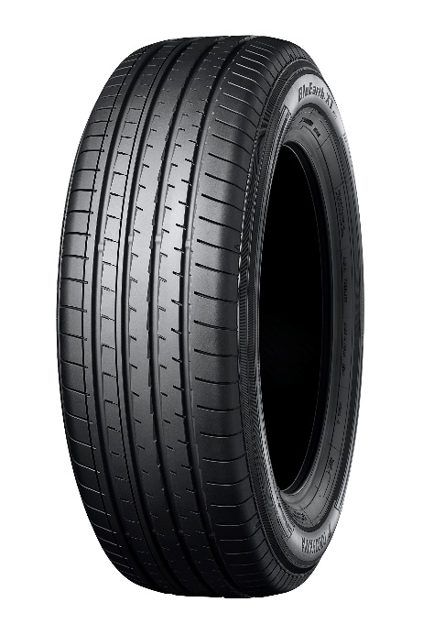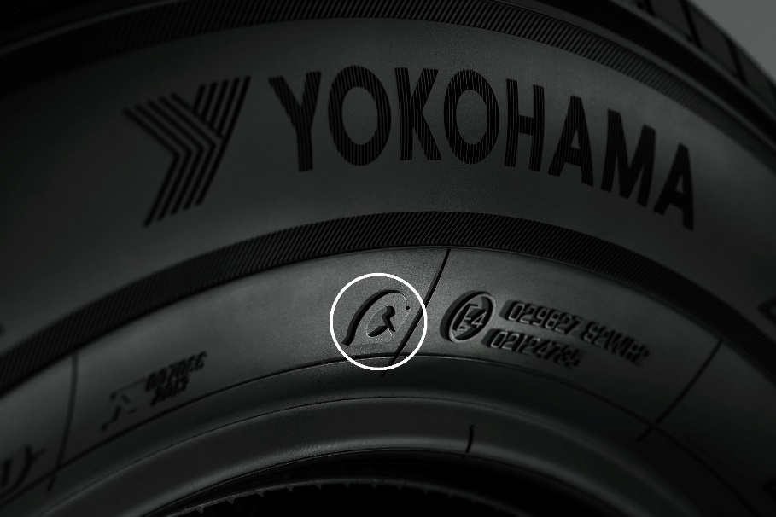
BluEarth-XT AE61 Mark on BluEarth-XT AE61 Z.P.S indicating conformity with the EMT standard

