6th April 2023

YOKOHAMA’s ADVAN wins Round 2 of the 2023 Nürburgring Endurance Series

YOKOHAMA is pleased to announce that a car running on its ADVAN global flagship brand racing tyres was the overall winner of the second round of the 2023 Nürburgring Endurance Series (NLS) held on 31st March – 1st April. The winning car was fitted with ADVAN A005 tyres for dry conditions and ADVAN A006 tyres for wet conditions. As part of this year’s ADVAN CHALLENGE that seeks to maximize sales of ADVAN tyres during the brand’s 45th year, a machine featuring ADVAN colours made a successful debut in NLS Round 2, racing to victory and leaving a strong impression of ADVAN brand tyres and their excellent performance.

The winning machine was the #34 BMW M4 GT3 entered in the NLS SP9 Pro class by Walkenhorst Motorsport, a BMW’s customer racing team. Drivers Jakub Giermaziak and Jesse Krohn steered the #34 machine to fourth place on a wet track in the qualifying race and then drove full throttle from start to finish without any trouble on a post-rain dry track in the final race, crossing the finish line 21.764 seconds ahead of the second-place car.

The NLS is an endurance race series run on the Nürburgring race track, widely considered the world’s most demanding course. The series’ early rounds are positioned as preludes to the Nürburgring 24-Hour Race to be held this May. This year, some 170 cars will be competing I the nine NLS races being held from March to October. YOKOHAMA is supplying ADVAN racing tyres to two ADVAN-coloured BMW M4 GT3 cars competing in the SP9 Pro class, including the Round 2 winning #34 car. The company also aims to win the overall championship at this May’s Nürburgring 24-Hour Race, where it will be supporting the same two cars.

Under YOKOHAMA’s three-year (2021–2023) medium-term management plan, Yokohama Transformation 2023 (YX2023), the consumer tyre business aims to maximize the sales ratios of high-value-added YOKOHAMA tyres, namely the global flagship ADVAN brand, the GEOLANDAR brand of tyres for SUVs and pick-up trucks, and various winter tyres. YX2023 also positions participation in motorsports activities as crucial to the company’s effort to develop new tyre technologies that will further strengthen the ADVAN and GEOLANDAR brands. YOKOHAMA therefore is again participating in a wide variety of motorsports events in Japan and around the globe, from top-category to grassroots events.

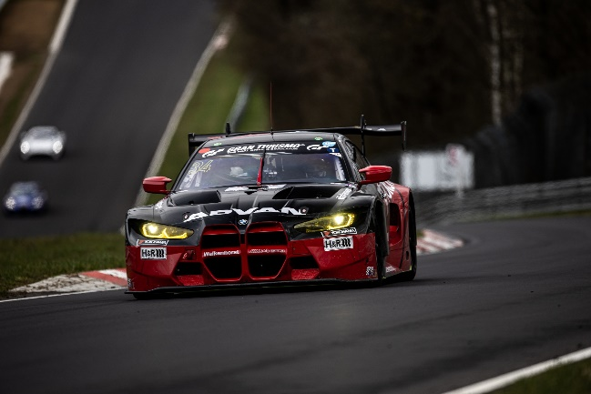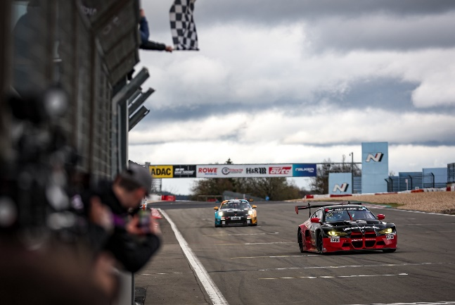
The #34 BMW M4 GT3 racing to victory in the second round of this year’s NLS

