30th January 2023

YOKOHAMA’s ADVAN tyres coming factory-equipped on Toyota’s new GR Corolla

YOKOHAMA announced today that it is supplying its ADVAN APEX V601 tyres as original equipment for Toyota Motor Corporation’s new GR Corolla, which was launched in Japan in early 2023 and has been gradually introduced to the overseas markets. The GR Corolla is being fitted with 235/40R18 91W size tyres.

The ADVAN APEX V601 tyre being fitted on the GR Corolla is a high-performance summer tyre that features the latest tyre technologies as well as an asymmetric tread pattern reminiscent of that first used on one the Company’s most historically important tyres, the YOKOHAMA A008. The ADVAN APEX V601 tyres provide the GR Corolla with strong gripping power as well as superior wet performance and handling performance.

Under YOKOHAMA’s current medium-term management plan, Yokohama Transformation 2023 (YX2023), the consumer tyre business aims to maximize the sales ratios of high -value-added YOKOHAMA tyres, namely the global flagship ADVAN brand, the GEOLANDAR brand of tyres for SUVs and pickup trucks, and various winter tyres. One of the key initiatives under this strategy is expanding the adoption of ADVAN and GEOLANDAR tyres as original equipment on new cars. YOKOHAMA also is strengthening sales of its ADVAN flagship brand in the replacement tyre market, where it introduced its ADVAN Sport V107 global flagship tyre and the ADVAN NEOVA AD09, a new high-performance street sports tyre, in 2022.

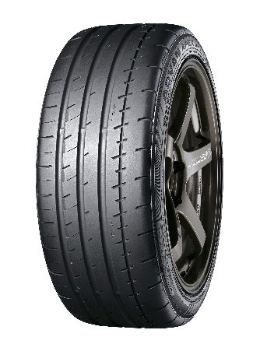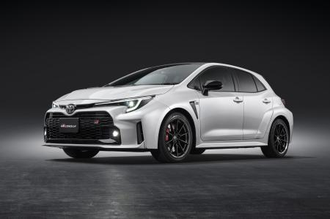

ADVAN APEX V601 *Tyre shown in photo differs in size from those used on the GR Corolla. (wheel shown is not standard equipment)
The new GR Corolla *The above photo is used with the permission of Toyota Motor Corporation. Reprint or other usage of this image without prior permission from Toyota Motor is strictly prohibited.

