7th December 2023

YOKOHAMA’s ADVAN dB V551 and ASPEC A349 tyres coming factory-equipped on Honda’s new Odyssey

YOKOHAMA announced today that it is supplying its ADVAN dB V551 and ASPEC A349 tyres as original equipment (OE) to Honda Motor Co., Ltd. for use on the car manufacturer´s new minivan, Odyssey, which will be launched in Japan in December 2023. The Odyssey is being equipped with the ADVAN dB V551 in the 225/50R18 95V size, and the ASPEC A349 in the 215/60R17 96H size.

The ADVAN dB V551 is a premium comfort tyre that achieves both advanced noise reduction and the uncompromised stability of the global flagship ADVAN brand. It also boasts excellent environmental performance. The ASPEC A349 is a summer tyre for passenger cars. It features excellent driving and safety performance, enabling a comfortable ride. Both tyres offer excellent driving stability, high rigidity, and a comfortable ride befitting the Odyssey, a luxury minivan.

Under YOKOHAMA’s three-year (2021–2023) medium-term management plan, Yokohama Transformation 2023 (YX2023), the consumer tyre business aims to maximize the sales ratios of high-value-added YOKOHAMA tyres, namely the global flagship ADVAN brand, the GEOLANDAR brand of tyres for SUVs and pick-up trucks, and various winter tyres. One of the key initiatives under this strategy is expanding the adoption of ADVAN and GEOLANDAR tyres as original equipment on new cars.

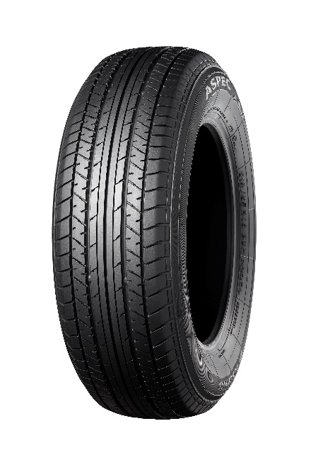
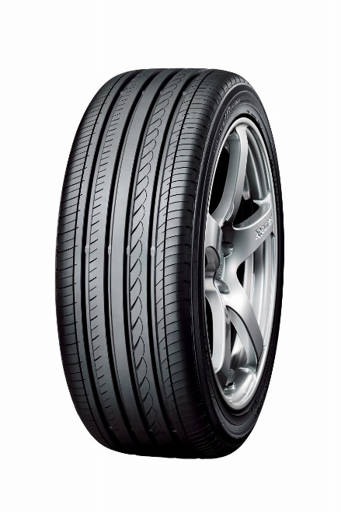
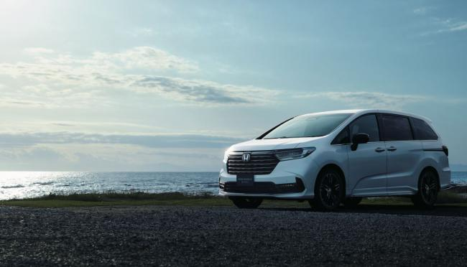
ADVAN dB V551 * The tyre shown in photo differs in size from those installed on the new Odyssey. (wheel shown is not standard equipment)
ASPEC A349 * The tyre shown in photo differs in size from those installed on the new Odyssey
Honda´s new Odyssey * The above photo is used with the permission of Honda Motor Co., Ltd. Reprint or other usage of this image without prior permission from Honda Motor Co., Ltd. is strictly prohibited.

