13th December 2023

YOKOHAMA’s ADVAN V61 tyres coming factory-equipped on the new Lexus LBX

YOKOHAMA announced today that it is supplying its ADVAN V61 tyres as original equipment (OE) to Lexus for use on the new compact SUVs, the LBX, sales of which will be launched in Japan, Europe, Asia and other markets in December 2023. The new LBX is being fitted with 225/55R18 98H and 225/60R17 99H.

The ADVAN V61 tyre being supplied as OE is a high-performance tyre in YOKOHAMA’s global flagship ADVAN brand. The tyres feature specially tuned tread, side walls and compound that deliver the stable handling and comfortable ride befitting a luxury compact SUV such as the LBX, while maintaining low rolling resistance and performance in dry and wet conditions.

The supplied tyres were developed by taking advantage of YOKOHAMA’s proprietary HAICoLab*, an AI-based development framework that aims to foster new discoveries and digital innovation by merging human inspiration and creativity with AI’s enormous data-processing capability. The innovative technologies applied in development of the tyres are based on new knowledge obtained by collecting actual data and virtual data generated by simulations and then using AI’s predict, analyse and search functions.
* An acronym for “Humans and AI ColLaborate” for digital innovation

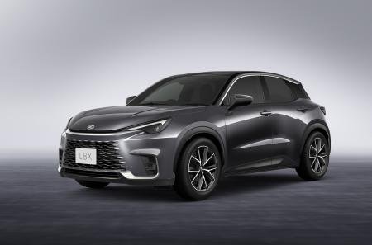
Under YOKOHAMA’s three-year (2021–2023) medium-term management plan, Yokohama Transformation 2023 (YX2023), the consumer tyre business aims to maximize the sales ratios of high-value-added YOKOHAMA tyres, namely the global flagship ADVAN brand, the GEOLANDAR brand of tyres for SUVs and pick-up trucks, and various winter tyres. One of the key initiatives under this strategy is expanding the adoption of ADVAN and GEOLANDAR tyres as original equipment on new cars.
New LBX
*The above photo is used with the permission of Lexus. Reprinting or other usage of this image without prior permission from Lexus is strictly prohibited.

ADVAN V61
*The tyre shown in the photo differs in size from those installed on the new LBX
HAICoLab conceptual diagram

