29th March 2024

YOKOHAMA’s ADVAN Sport V107 tyres coming factory-equipped on the new Mercedes-AMG CLE 53 4MATIC+ Coupé
YOKOHAMA announced today that it is supplying its ADVAN Sport V107 tyres as original equipment (OE) for the new Mercedes-AMG CLE 53 4MATIC+ Coupé, which was presented in December 2023. The Coupé is being fitted with 265/40ZR19 (102Y) front tyres and 295/35ZR19 (104Y) rear tyres.
The ADVAN Sport V107 is an ultra-high performance tyre under the ADVAN brand, YOKOHAMA’s global flagship tyre brand, and is targeted for use on premium car categories. The tyres are jointly developed with leading premium car manufacturers and put through rigorous testing at YOKOHAMA’s test centre at the Nürburgring, widely considered to be the world's most demanding test course. The ADVAN Sport V107 being fitted on the new CLE 53 4MATIC+ Coupé was jointly developed with Mercedes-AMG. The tread pattern is designed to deliver a quiet ride, and the tyre’s groove area and a compound have been adjusted to achieve superior performance in dry and wet road conditions. The application of YOKOHAMA’s proprietary mound profile technology, which evenly distributes surface contact pressure, further enhances the tyres’ dry performance. Additionally, the optimized casing rigidity contributes to the excellent steering stability that is essential for high-power premium cars while also improving fuel efficiency. The tyre accordingly features the Mercedes-AMG’s “MO1” mark of approval on the sidewall. In addition to the new CLE 53 4MATIC+ Coupé, the ADVAN Sport V107 tyres won factory fitments on a long list of Mercedes-AMG models. Currently, the tyres are equipped on the EQS 53 4MATIC+ and the GLB 35 4MATIC.
Under YOKOHAMA’s three-year (2024–2026) medium-term management plan, Yokohama Transformation 2026 (YX2026), the consumer tyre business aims to maximize the sales ratios of high-value-added tyres. One of the key initiatives under this strategy is promoting the global flagship ADVAN brand tyres and the GEOLANDAR brand tyres for SUVs and pick-up trucks as original equipment for new cars.
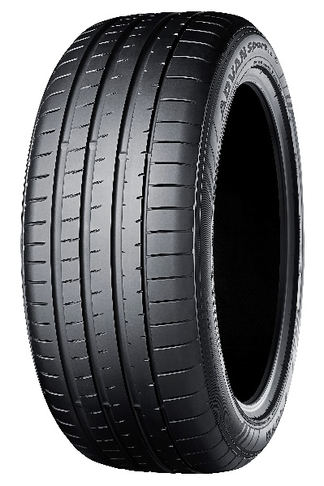
ADVAN Sport V107 *Tyre shown in photo differs in size from those installed on the new Mercedes-AMG CLE 53 4MATIC+ Coupé

