7th February 2023

YOKOHAMA opens Japan’s largest Indoor Ice Circle Test Facility at its Tire Test Center of Hokkaido

YOKOHAMA announced today that on January 5 it began operating a new indoor ice circle test facility at its Tire Test Center of Hokkaido (TTCH). The new facility is dedicated to testing winter tyres’ turning performance on an icy surface and is Japan’s largest indoor facility for testing tyre turning performance on ice.

The new facility was established to further improve YOKOHAMA tyres’ turning performance on ice, which is the second most important tyre performance on icy roads, after braking performance. Compared to outdoor test sites, the new indoor facility is unaffected by changing outdoor weather conditions and temperatures, and the ice surface’s condition can be stably maintained. As a result, the accuracy of test data can be improved, facilitating efficient development of more advanced technologies. The new facility is housed in a 56m×56m building with a ceiling height of 12.3m (at highest point), and its 1,960m2 ice surface enables testing at turning radiuses of 10-22m.

Since opening TTCH in December 2015, YOKOHAMA has introduced more advanced and sophisticated testing and evaluation methods in support of the global expansion of its tyre business. In January 2018, TTCH opened its first indoor facility with an ice track for testing winter tyres. In November 2020, the facility was upgraded by installing Japan’s largest indoor cooling unit, which enables setting the temperature of the ice surface anywhere between -10°C and 0°C (14°F and 32°F)*.The newly completed indoor ice circle test facility is adjacent to the previously established indoor ice-surface test facility, which will facilitate efficient combination testing using both facilities and accelerate the development of winter tyres that deliver the highest level of safety for driving on icy roads.
*At a standard room temperature of 5°C (41°F)

In addition to the winter tyre test facilities at TTCH, YOKOHAMA conducts winter tyre testing at the Yokohama Test Center of Sweden (YTCS). TTCH handles testing of YOKOHAMA tyres sold in various markets around the world, and YTCS conducts additional tests to confirm the suitability and performance of tyres to be sold in Europe. These two test facilities contribute to YOKOHAMA’s development of tyres most suitable to the winter road conditions in the country or region of use.

Under YOKOHAMA’s three-year (2021–2023) medium-term management plan, Yokohama Transformation 2023 (YX2023), the consumer tyre business aims to maximize the sales ratios of high-value-added YOKOHAMA tyres, namely the global flagship ADVAN brand, the GEOLANDAR brand, and various winter tyres including all-season tyres.

Profile of YOKOHAMA’s Tire Test Center of Hokkaido (TTCH)
Start of operations: | December 2015
Location: | 500 Kamiubun, Kamui-cho, Asahikawa City, Hokkaido Prefecture
Site area: | 906,462 square meters
Tested products: | Winter tyres used on passenger cars, trucks and buses (also tests summer tyres  from spring to autumn)
Test courses: | A 2.3-kilometer circuit that includes a 1-kilometer straightaway for testing at  speeds of up to more than 100 kilometres per hour on hard snow; an ice track; a  snow and ice hill track; snow and ice circles; and a 1.1-kilometer snow-surface  handling track that spans a gradient of 5%

Profile of TTCH’s Indoor Ice Circle Test Facility
Building size: | 56 meters long, 56 meters wide, 12.3 meters high (at highest point)
Total floor area: | 3,136 square meters
Ice surface area: | 1,960 square meters
Testing turn radius: | 10–22 meters
Construction: | Steel-framed single-story structure
Start of operations: | January 2023

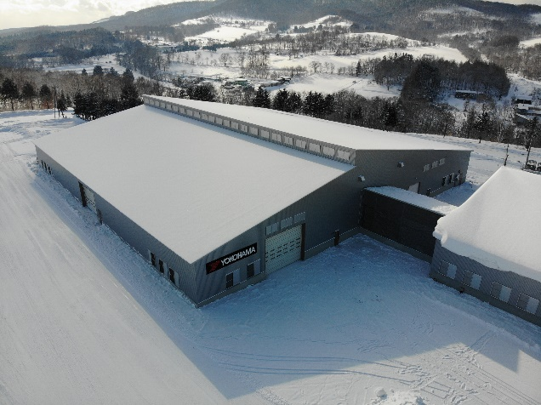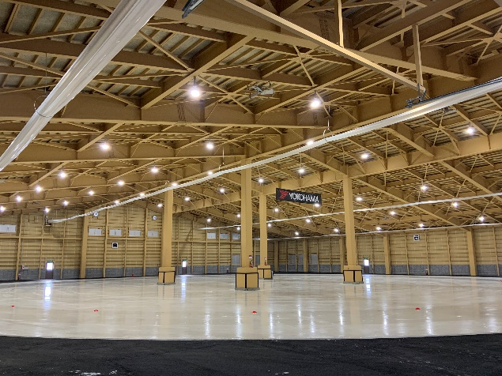
Exterior of the new indoor ice circle test facility Inside the indoor ice circle test facility

