17th February 2022

YOKOHAMA now supplying its ADVAN Sport V107 for Mercedes-AMG’s new EV sedan, the EQS 53 4MATIC+

YOKOHAMA announced today that it has begun delivering ADVAN Sport V107 tyres for use as original equipment (OE) on Mercedes-AMG’s first electric vehicle (EV), the Mercedes-AMG EQS 53 4MATIC+, which was announced in September 2021. The new EV is being fitted with 275/35R22 104Y size front and rear tyres.

The “ADVAN Sport V107” is a high-performance tyre in YOKOHAMA’s global flagship ADVAN brand. The tyres being supplied were codeveloped by YOKOHAMA and Mercedes-AMG to meet the German carmaker’s highest technological standards. To achieve the high level of rolling resistance required for EVs, the tyres use a newly developed compound that reduces heat generation during normal driving more than tyres previously supplied to Mercedes-AMG. In addition, the tyre’s profile structure, crucial for uniform road contact pressure, and a newly developed pattern arrangement reduce acceleration passing noise in line with United Nations Economic Commission for Europe regulation UN-ECE R51-03. The new ADVAN Sport V107’s combination of excellent driving performance and environment-friendly features make it a perfect tyre for the Mercedes-AMG EQS 53 4MATIC+, the Mercedes-AMG brand’s first EV. The tyre accordingly features the Mercedes-AMG’s “MO1” mark of approval on the sidewall.

Under YOKOHAMA's current medium-term management plan, Yokohama Transformation 2023 (YX2023), the consumer tyre business aims to maximize the sales ratios of high-value-added YOKOHAMA tyres, namely the global flagship ADVAN brand, the GEOLANDAR brand of tyres for SUVs and pick-up trucks, and various winter tyres. One of the key initiatives being implemented under this strategy is the expansion of ADVAN and GEOLANDAR tyres as original equipment on new cars.

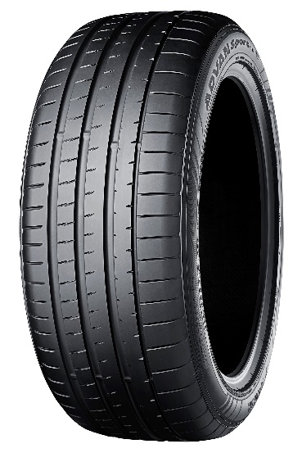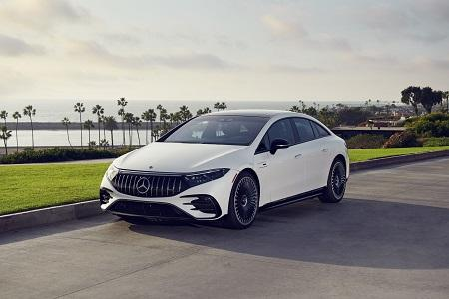
Mercedes-AMG EQS 53 4MATIC+ *The above photo is used with the permission of Mercedes-AMG. Reprint or other usage of this image without prior permission from Mercedes-AMG is strictly prohibited.
Mercedes-AMG EQS 53 4MATIC+ *The above photo is used with the permission of Mercedes-AMG. Reprint or other usage of this image without prior permission from Mercedes-AMG is strictly prohibited.
The ADVAN Sport V107,
size 275/35R22 104Y,
adopted as OE on
Mercedes-AMG EQS 53 4MATIC+

