2nd February 2024

YOKOHAMA now applying its proprietary “E+” mark on truck and bus tyres

Strengthening the global appeal of its tyres for electrified vehicles

YOKOHAMA announced today that it has begun applying its proprietary “E+” mark on its tyres for trucks and buses. The “E+” mark, which indicates the tyre has special qualities suitable for electrified vehicles, was first applied to YOKOHAMA passenger car tyres in the latter half of 2023 in a move to strengthen the appeal of YOKOHAMA tyres for electrified vehicles. The first truck or bus tyres to bear the “E+” mark will be a tyre sold for use on buses in Japan and another one for buses in Europe.

YOKOHAMA is applying its “E+” mark only to its tyres that feature technologies that meet the unique needs of electrified vehicles. For example, the tyres must have the strength to withstand the higher loads associated with heavy electric batteries as well as the electric motor’s high torque output. The tiyes also must have a quietness quality that complements the lack of noise from the vehicle’s engine. They also must contribute to the vehicle’s efficient use of electricity and other energy sources and expand the vehicle’s driving range. In addition to being displayed on the sidewall of YOKOHAMA tyres suitable for electrified vehicles, the “E+” mark will be prominently displayed in tyre catalogues and websites to facilitate customers’ tyre selection. The first YOKOHAMA tyre to bear the “E+” mark was the new ADVAN Sport EV, an ultra-high performance summer tyre for EVs that YOKOHAMA introduced in Europe and other markets in autumn 2023. The next passenger car tyre to bear the “E+” mark will be the new ADVAN dB V553 premium comfort tyre introduced this February.

The first YOKOHAMA bus tyres to bear the “E+” mark are the 507U sold in Japan and the 120U sold in Europe. YOKOHAMA expects the 507U’s enhanced durability and wear resistance when used on low-floor buses and increased ability to be retread will enhance its appeal for use on EV buses in Japan. The 120U meets the stringent requirements of the leading transport company in Spain, where use of electrified vehicles is being promoted, and therefore delivers the high performance that meets the specific needs of the EV buses in throughout Europe. YOKOHAMA reached an agreement with the Spanish company in September 2023 to begin delivering tyres for its EV buses.

To meet expanding demand for tyres suitable for use on electrified vehicles, YOKOHAMA is strengthening its development of passenger car and truck/bus tyres suitable for use as original equipment on electrified vehicles. YOKOHAMA will continue to expand the application of its proprietary “E+” mark on its tyres suitable for use on electrified vehicles as it seeks to raise the awareness of users around the world of its tyres’ suitability for use on electric vehicles.

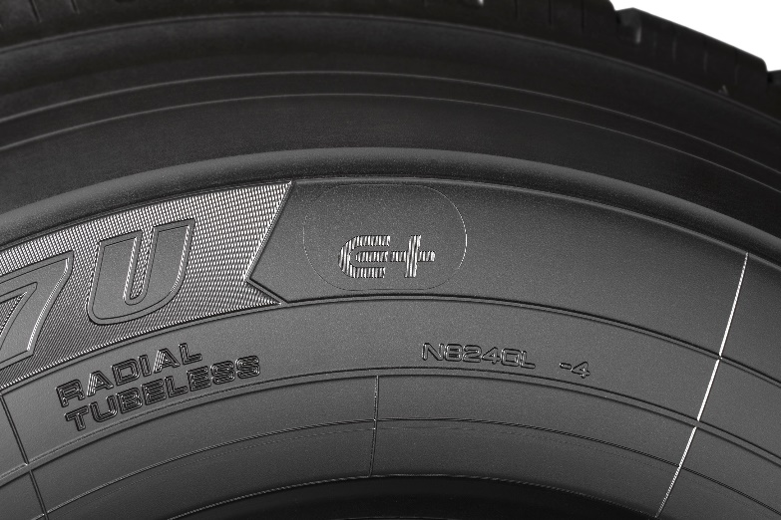
“E+” mark on the sidewall of a 507U tyre

