15th March 2023

YOKOHAMA launches the flame-retardant Hamaheat #2110

YOKOHAMA announced today that it has launched a new conveyor belt, the flame-retardant Hamaheat #2110, which combines medium-heat resistance and flame-retardant properties. This is the second product in the series of flame-retardant belts that combine heat resistance and flame-retardant properties, following the release of the flame-retardant Hamaheat Super 100, launched in 2021.

In recent years, the need for conveyor belts with a flame-retardant (self-extinguishing) property that prevents belts from burning up, combined with heat-resistance property has increased at conveyor belt lines that transport high-temperature or medium-temperature substances such as sintered ores^{*1}, cokes^{*2}, and other sintered products^{*3}. To meet this need, YOKOHAMA has developed this new product that successfully combines these two important properties in the medium-temperature range, by utilizing its distinctive rubber compounding technology accumulated from experiences in development of a wide range of heat-resistant and flame retardant belts.

This new product has been developed based on the company’s heat-resistant conveyor belt Hamaheat #2110, which is well known in the market with its medium-temperature heat resistance and durability under strenuous operating conditions. Like heat-resistant Hamaheat #2110, this new product is capable of transporting materials with a temperature range from 70℃/160℉ to 200℃/390℉ (Lumps: from 70℃/160℉ to 200°C/390℉, Powder: from 70℃/160℉ to 150℃/300℉), and operating at belt surface temperatures from 60℃/140℉ to 100℃/210℉ range, while achieving the Japanese Industrial Standards JIS K 6324:2013 Grade 3 rating for flame retardant rubber conveyor belts.

YOKOHAMA is currently implementing its Yokohama Transformation 2023 (YX2023) medium-term management plan for fiscal years 2021–2023. The plan calls for the MB segment to concentrate its resources in its two strongest business domains - hoses & couplings and industrial products - as its aims to become a growth driver capable of generating stable profits. The MB segment’s industrial materials business aims to establish a dominant presence in the conveyor belt market, where it has had considerable success in the past.

*1: A material made by mixing powdered iron ore with powdered coke and limestone and then baked to a certain size
*2: An extract material created by heating coal at high temperatures
*3: A material formed from metal or ceramic powder and hardened at a temperature lower than the melting point

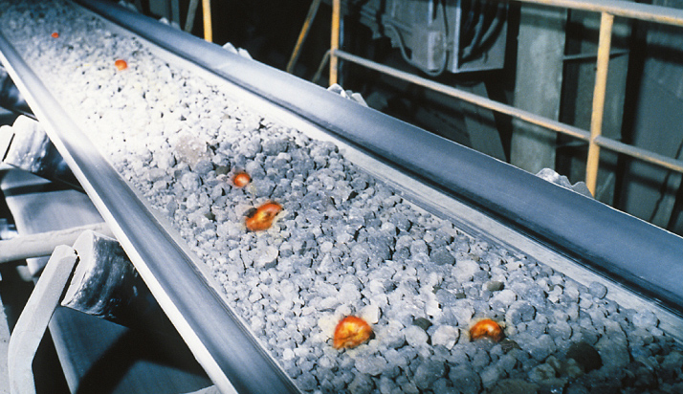
Hamaheat #2110 (image)

<Flame-retardant testing with burner>

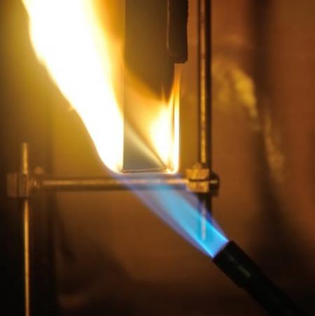
Igniting with burner
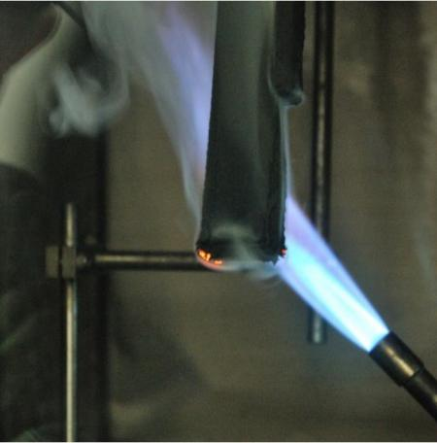
Just before ignition stop

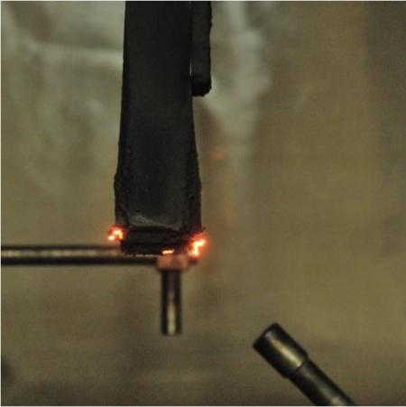
One minute after ignition stop/ Start blowing air

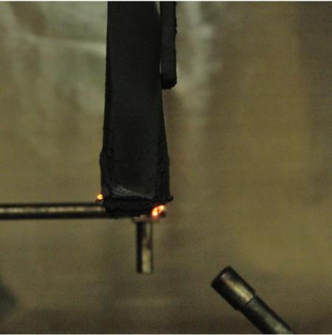
One minute after blowing air

