12th November 2021

YOKOHAMA launches the flame-retardant Hamaheat Super 100

YOKOHAMA announced today that it has launched a new conveyor belt, the flame-retardant Hamaheat Super 100, which combines high-heat resistance and flame-resistance properties.

In recent years, the need for conveyor belts with a flame-retardant (self-extinguishing) property that prevents belts from burning up, combined with heat-resistance property has increased at conveyor belt lines that transport high-temperature substances such as sintered ores^{*1}, cokes^{*2}. To meet this need, YOKOHAMA has developed this new product that successfully combines these two important properties, by utilizing its distinctive rubber compounding technology accumulated from experiences in development of a wide range of heat- and flame-resistant belts.

This new product has been developed based on the Company’s heat-resistant conveyor belt Hamaheat Super 100, which is well known in the market with its high-temperature heat resistance and durability under strenuous operating conditions. Like Hamaheat Super 100, this new product is capable of transporting materials with a temperature range of 100–400°C and operating at belt surface temperatures in the 60–200°C range, while achieving the Japanese Industrial Standards JIS K 6324:2013 Grade 3 rating for flame resistant rubber conveyor belts.

YOKOHAMA is now implementing the Yokohama Transformation 2023 (YX2023) medium-term management plan that will guide the company from 2021 through 2023. Under this plan, the MB segment will concentrate its resources in its two strongest business domains - hose & couplings and industrial products - as it aims to become a growth driver capable of generating stable profits. The MB segment’s industrial materials business aims to establish a dominant presence in the conveyor belt market, where it has had considerable success in the past.

*1: A material made by mixing powdered iron ore with powdered coke and limestone and then baked to a certain size.
*2: An extract material created by heating coal at high temperatures.

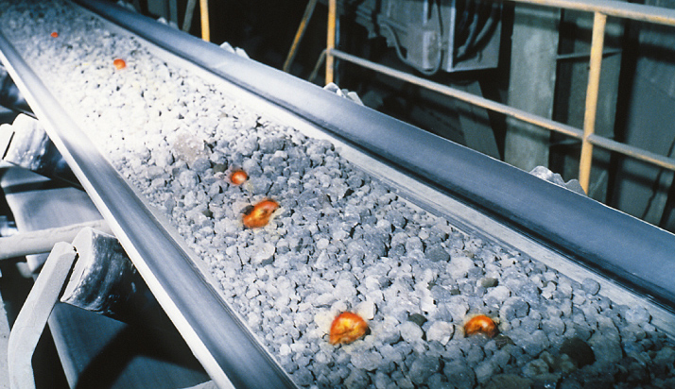
Flame-retardant Hamaheat Super 100 (Image)

