15th March 2023

YOKOHAMA launches high-temperature heat-resistant conveyor belt Hamaheat Super 80

YOKOHAMA announced today that it has launched the Hamaheat Super 80, a high-temperature heat-resistant conveyor belt from its popular Hamaheat series.

Major industries utilizing high-temperature heat-resistant belts are steel and cement, and they are used to transport high-temperature or medium-temperature materials such as sintered ores^{*1}, cokes^{*2}, sintered products^{*3}, and clinkers^{*4}. The conveyor belt surface temperature increases due to operating conditions, such as the temperature of the material being conveyed and ambient temperature, causing the belt to deteriorate and shortening its service life. For this reason, there is demand for a product that prevents deterioration by giving the belt heat resistance properties. In response to this demand, harnessing its distinctive rubber compounding technologies accumulated through the development of a wide range of heat- resistant belts, YOKOHAMA has developed the Hamaheat series.

The Hamaheat Super 80 is a middle grade product based on the Hamaheat Super 100, a high- grade product in the Hamaheat series that has gained a strong reputation for its high temperature heat resistance, and was developed with the aim of providing a product that offers superior cost performance by optimizing performance to better suit operating conditions. With superior heat aging resistance and wear resistance, this conveyor belt is ideal for high-temperature conveyance up to an allowable belt surface temperature of 180°C/350°F, and is perfect for the conveyance of cement clinker.

YOKOHAMA is currently implementing its Yokohama Transformation 2023 (YX2023) medium- term management plan for fiscal years 2021–2023. The plan calls for the MB segment to concentrate its resources in its two strongest business domains - hoses & couplings and industrial products - as its aims to become a growth driver capable of generating stable profits. The MB segment’s industrial materials business aims to establish a dominant presence in the conveyor belt market, where it has had considerable success in the past.

*1: A material made by mixing powdered iron ore with powdered coke and limestone and then baked to a certain size
*2: An extract material created by heating coal at high temperatures
*3: A material formed from metal or ceramic powder and hardened at a temperature lower than the melting point
*4: A raw cement material produced by sintering limestone in a kiln and is made by firing and hardening minerals and other materials

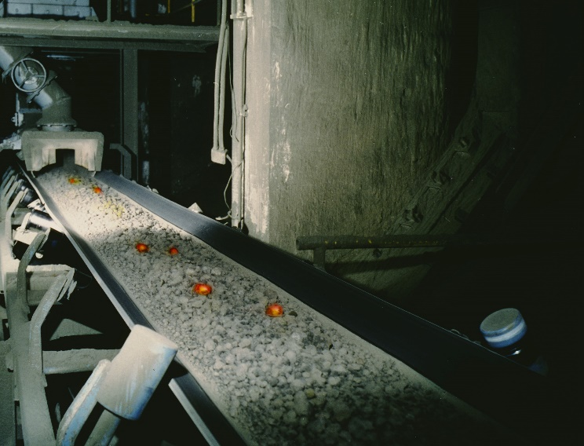
Hamaheat Super 80 (image)

Line-up and features of high-temperature heat-resistant conveyor belts
Product name | Super 80 (new) | Super 100
Grade | Middle Grade | High Grade
Allowable belt surface temperature | From 60°C/140°F to 180°C/350°F | From 60°C/140°F to 200°C/390°F
Wear resistance | ○  Superior wear resistance after heat aging | ◎  Exceptional wear resistance after heat aging
Crack resistance | ○  Superior crack resistance after heat aging | ◎  Exceptional crack resistance after heat aging

