16th February 2012

YOKOHAMA to Release New GEOLANDAR SUV Tyre in Europe

The YOKOHAMA Rubber Co., Ltd., announced today that it will release a new product for SUVs under its GEOLANDAR tyre brand – the GEOLANDAR SUV – in Europe in March.

A next-generation SUV tyre enhances fuel efficiency. It will be available in 27 sizes from 245/50R20 102V to 205/70R15 96H. First sold in Japan in February, it will be released gradually throughout the world, starting with Europe.
The GEOLANDAR SUV is marketed for vehicles designed for on-road driving, including urban crossover vehicles and medium- and small-size SUVs, which are increasingly popular around the world. In its development, employing for the first time in SUV tyres the BluEarth concept of “being human and socially friendly combined with improvements to environmental performance,” YOKOHAMA adopted the latest compounding and design technology used in its fuel-efficient BluEarth tyres for passenger cars. Thanks to these technologies, comfort, safety and lower fuel consumption are enhanced while the utility performance of SUV tyres on various road surfaces is fully maintained. YOKOHAMA’s BluEarth concept mark appears on the sidewall of each tyre.

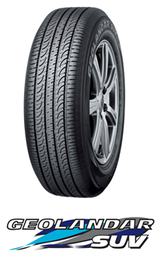
GEOLANDAR tyres are sold around the world and are popular for their high levels of performance. Five models are currently available in Europe: the GEOLANDAR H/T-S for large and on-road SUVs, the GEOLANDAR A/T-S for all-around use, the off-road GEOLANDAR M/T+, and the GEOLANDAR I/T+ and GEOLANDAR I/T-S, both for winter driving. With addition of the GEOLANDAR SUV, YOKOHAMA increases its ability to meet the diverse needs of SUV users.

