16th February 2012

YOKOHAMA to Release Fuel-Efficient Passenger-Car Tyre BluEarth AE-01 in Europe

Bringing Fuel Efficiency to More People with the "Environmentally, Human and Socially Friendly" Global Brand BluEarth

The YOKOHAMA Rubber Co., Ltd., announced today that it will release a new tyre, the BluEarth AE-01, in the European market in March. The AE-01 is a standard tyre for passenger cars in the fuel-efficient BluEarth tyre series. It will be available in 40 sizes from 205/55R16 91H to 155/80R13 79T. It will be sold around the world, starting in Europe.

YOKOHAMA developed the BluEarth AE-01 primarily for compact cars, demand for which is increasing, and because it sought to make a greater contribution to global environmental preservation by facilitating use by more people of fuel-efficient tyres. BluEarth Technology, adopted in the flagship BluEarth-1 under Yokohama’s BluEarth tyre series, was used and tuned to the creation of standard products. Through materials and technologies such as nano blend rubber, orange oil, aerodynamic design and weight reduction, high levels of safety and comfort have been achieved in addition to fuel-efficient performance. Surrounding living environments also benefit from the noticeably reduced external rolling noise.

With the BluEarth-1 having been released in the European market in April 2011, the BluEarth AE-01 will be the second product under the BluEarth brand name. In addition to the series itself, tyres developed based on the BluEarth concept carry the BluEarth concept mark on each sidewall.

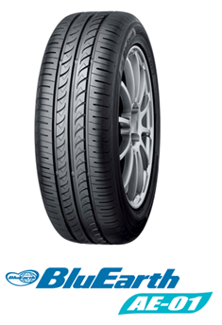
BluEarth represents YOKOHAMA´s global concept of “being human and socially friendly combined with improvements to environmental performance,” and activities under the concept are being carried out around the world. Using technologies fostered through its development and sale of fuel-efficient tyres over many years, YOKOHAMA aims in the creation of tyres based on the BluEarth concept not only to achieve good fuel efficiency but to reduce stress on drivers, passengers and surrounding environments – to be, in other words, “friendly.”

