25th October 2023

YOKOHAMA issues “Integrated Report 2023”

YOKOHAMA announced today that it posted the English-language version of its “Integrated Report 2023” on the Company’s English Sustainability website. The report includes a comprehensive presentation of YOKOHAMA’s management strategies and business activities.

“Integrated Report 2023” on YOKOHAMA’s “Sustainability” website
https://www.y-yokohama.com/global/sustainability/information/backnumber_report/

Under Yokohama Transformation 2023 (YX2023), the Company’s medium-term plan for fiscal years 2021–2023, YOKOHAMA is implementing sustainability management that integrates ESG into its business strategies. Accordingly, the Company is accelerating business activities that will lead to sustainable enhancement of its corporate value while contributing to local communities and the resolution of social issues.

To facilitate the stakeholders’ proper understanding of a comprehensive presentation of YOKOHAMA’s management strategies and business activities, in 2022 YOKOHAMA began publishing an integrated report that includes a well-organized presentation of such key financial information as management strategies and business performance as well as important non-financial information regarding the Company’s social, environmental, human resources, and corporate governance policies and activities. Referencing the International Integrated Reporting Framework advocated by the International Financial Reporting Standards (IFRS) Foundation and the Japan Ministry of Economy, Trade and Industry's Guidance for Collaborative Value Creation, the report’s structure and contents place an emphasis on the perspectives of all YOKOHAMA stakeholders.

Incorporating feedback received from stakeholders about the 2022 report, “Integrated Report 2023” includes more detailed information on the Company’s financial and non-financial initiatives in order to facilitate and deepen readers’ understanding of the business model and the Yokohama Rubber Group “Value Creation Story” that are the basis for those initiatives aimed at achieving the goals of YX2023 and the sustainable growth of the Group.

The Yokohama Rubber Group looks forward to communicating with stakeholders through various opportunities and will continue to proactively provide fair and transparent information disclosures through various methods, such as the recently released “Integrated Report 2023.”

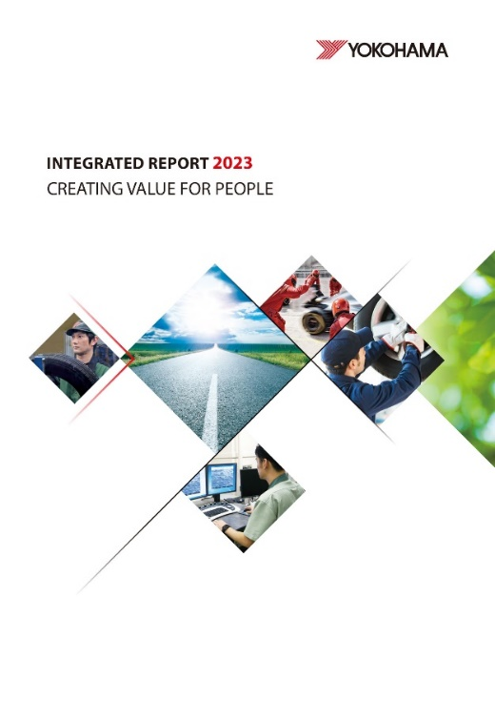
“Integrated Report 2023” cover

“Integrated Report 2023” contents
Who We Are
Corporate Philosophy; At a Glance; Brands Supporting YOKOHAMA’s “Exploitation” and “Exploration;” Pioneering History; Special Feature: Helping Transform the Mobility Industry by Strengthening our Presence in the OHT Business

Value Creation Journey
Message from the President; Value Creation Process; Sources of Value Creation; Risks and Opportunities in Sustainability Management & Materiality; Looking Back on Past Medium-Term Management Plans; Medium-term Management Plan YOKOHAMA Transformation 2023 (YX2023); Research & Development; Production & Quality; Motorsports Activities; Financial Strategy and Shareholder Return Policy; Financial & Non-Financial Highlights

Sustainability
YOKOHAMA’s Sustainability; Respect for Human Rights; Diversity & Inclusion; Special Feature: Promoting the Active Participation of Women at Production Sites in India; Work Style Reforms; Human Resources Development; Occupational Health and Safety; Supply Chain Management; Coexistence with Local Communities; Information Disclosure Based on TCFD Recommendations; Contributing to Reducing Environmental Impact

Governance
Dialogue Between Outside Directors; Corporate Governance; Compliance; Risk Management; Senior Management

Data Section
11-year Key Financial and Non-Financial Data; Financial Section; Glossary; Investor FAQ; Corporate Data; Share Information

