31st October 2022

YOKOHAMA issues “Integrated Report 2022”

YOKOHAMA announced today that on October 31 it posted the English-language version of its “Integrated Report 2022” on the Company’s English CSR website. The report includes a comprehensive presentation of YOKOHAMA’s management strategies and business activities. The original Japanese was posted on the Company’s Japanese CSR website on 31st August.

English “Integrated Report 2022” on CSR website
https://www.y-yokohama.com/global/csr/information/backnumber_report/

Under Yokohama Transformation 2023 (YX2023), the Company’s medium-term plan for fiscal years 2021–2023, YOKOHAMA is implementing ESG management that integrates ESG into its business strategies. Accordingly, the Company is accelerating business activities that will lead to sustainable enhancement of its corporate value while contributing to local communities and the resolution of social issues.

To communicate the Yokohama Group’s “value creation” that is generated by its management
strategies and business activities to stakeholders in an easy-to-understand manner, YOKOHAMA has consolidated the annual report and CSR report issued in past years into a single integrated report. “Integrated Report 2022” is a well-organized and comprehensive presentation of such key financial information as management strategies and business performance as well as important non-financial information regarding the Company’s social, environmental, human resources, and corporate governance policies and activities. Referencing the "International Integrated Reporting Framework" advocated by the International Integrated Reporting Council (IIRC) and the Japan Ministry of Economy, Trade and Industry's “Guidance for Collaborative Value Creation,” the new integrated report’s structure and contents were decided with careful consideration of the perspectives of all stakeholders and other potential readers.

In addition to an opening “Message from the President” in which Yokohama Rubber’s President and Chairman of the Board Masataka Yamaishi presents the Group’s current state and vision for the future, Integrated Report 2022 includes chapters entitled “Value Creation Stories,” which introduces the Group's diversified efforts to create value; “Growth Strategies,” which outlines the strategy for each of the Group’s businesses; “Financial & Non-Financial Highlights,” which graphically displays the Group’s business results and progress of its ESG initiatives; “Initiatives of Sustainability,” which introduces the Group’s wide-ranging ESG activities; and “Corporate Governance,” which presents management’s policies designed to earn the unwavering trust of all stakeholders and society. The report also includes a dialogue with a stakeholder and messages from outside directors.

The Yokohama Rubber Group looks forward to communicating with stakeholders through various opportunities and will continue to proactively provide fair and transparent information is closures through various methods, such as the recently released “Integrated Report 2022”.

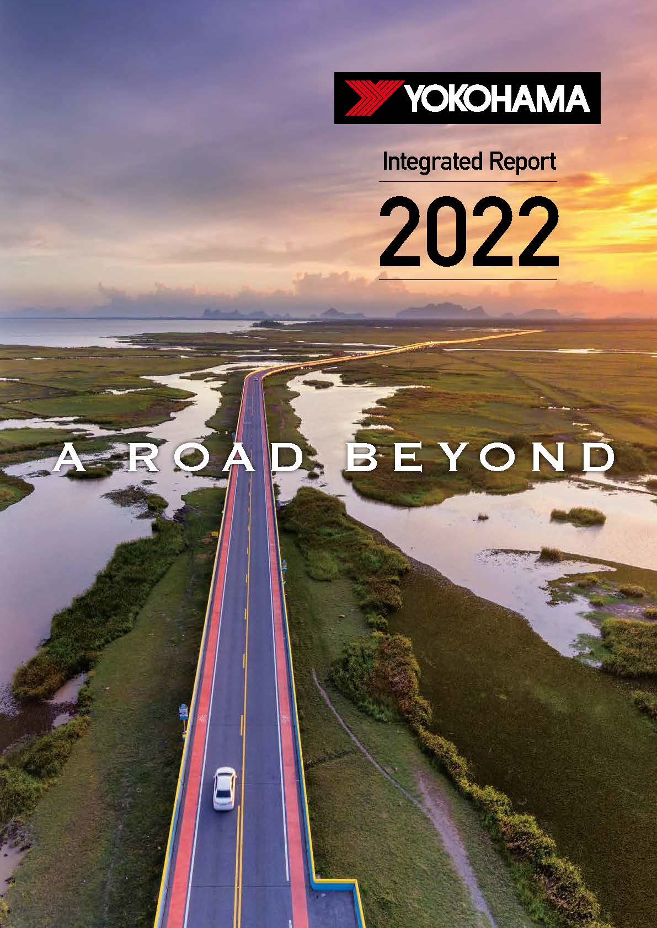
Front cover of “Integrated Report 2022”

