29th June 2022

YOKOHAMA is King of the Mountain at Pikes Peak

On a cold, wet, foggy day on the mountain, YOKOHAMA shined brightest. At the 100th running of the legendary Broadmoor Pikes Peak International Hill Climb, YOKOHAMA drivers thoroughly dominated the field on ADVAN tyres, culminating with Robin Shute’s overall championship and unlimited class win. All told, YOKOHAMA drivers had 10 podium finishes (out of 18), four class wins and four of the top five overall finishers. See the official race results here.

“What an incredible day!” said Fardad Niknam, Senior Director of product planning and product marketing of YOKOHAMA US-based subsidiary Yokohama Tire Corporation. “We worked closely with Robin and all our drivers to make sure they had the right tyres for the incredibly difficult weather conditions on the mountain, and everyone’s hard work paid off. Congratulations to Robin and his team, as well as all our drivers. Job well done!”

Shute was the big story. Running on ADVAN A005 tyres, the two-time overall champion claimed his third title in four years in his 2018 Wolf GB08 TSC-LT with a time of 10:09.525. “The tyres were incredible,” Shute said after the race. “While everyone was struggling with tyre temperatures, we just continued pushing and pushing on the YOKOHAMAs.”

Other first-place winners on ADVANS included:
-- David Donohue, time attack class. He drove his 2019 Porsche GT2 RS Clubsport (on ADVAN A052 tyres) to a winning time of 10:35.830.
-- Codie Vahsholtz, open wheel class: 2013 Ford Open (A005/A006™ tyres), 10:38.259.
-- Cam Ingram, Porsche Pikes Peak Trophy by Yokohama class, 2020 Porsche GT4 Clubsport (ADVAN A052), 11:22.691

Placing second for YOKOHAMA were:
-- Daijiro Yoshihara, exhibition class, 2018 Tesla Model 3, 11:06.205.
-- Derek Boyd, unlimited class, 2008 Mitsubishi Lancer Evolution X, 10:43.511.
-- Paul Dallenbach, open wheel class, 2020 Sierra Alpha, 11:06.387.
-- Loni Unser (Pikes Peak rookie), Porsche Pikes Peak Trophy by Yokohama class, 2019 Porsche GT4 Clubsport, 12:55.774.

Along with the Porsche Pikes Peak Trophy by Yokohama, YOKOHAMA’s extensive list of 2022 North American-based motorsports activities – both on- and off-road – includes the Porsche Sprint Challenge North America by Yokohama, Yokohama Drivers Cup USA, Global Time Attack and Super Lap Battle USA, Nitro Rallycross, SCORE, Crandon International Raceway sponsorship, 24 Hours of Lemons, Subaru Motorsports USA partnership, Yokohama NORRA Mexican 1000, Yokohama Tire Jeepspeed Race Series, TrophyLite Series, Championship Off-Road Series Partnership and Yokohama Sonora Rally.

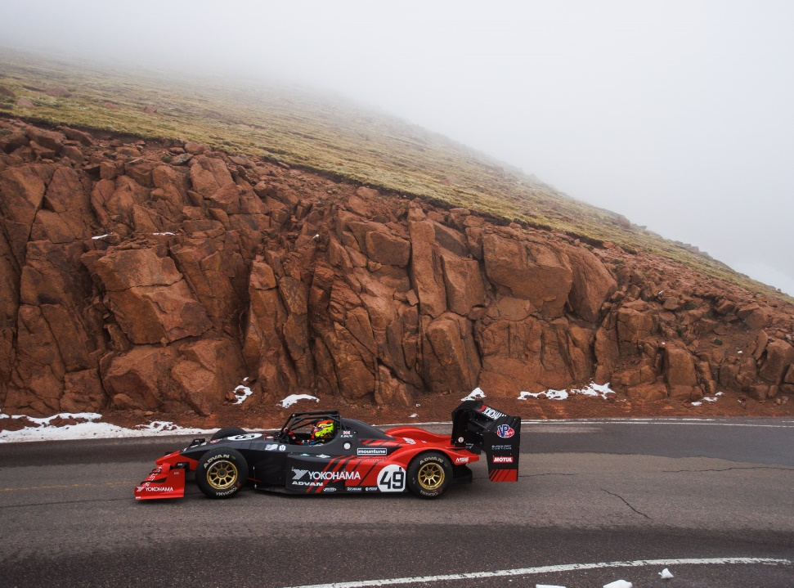
Robin Shute, 2022 Pikes Peak overall champion. photo by Larry Chen

