12th July 2023

YOKOHAMA introduces “E+”, a proprietary mark to be applied to its tyres with qualities needed by electrified vehicles

YOKOHAMA announced today that from the second half of 2023 it will be applying a new proprietary “E+” mark to its tyres for passenger cars, trucks, and buses that have special qualities needed by electrified vehicles*. The new “E+” mark is the latest facet of YOKOHAMA’s response to the rising demand in recent years for tyres most suitable for use on electrified vehicles.
* “Electrified vehicles” is a generic term for battery electric vehicles (BEVs), electric vehicles (EVs), plug-in hybrid vehicles (PHEVs), hybrid electric vehicles (HEVs), and fuel-cell electric vehicles (FCEVs).

Tyres installed on electrified vehicles must be able to meet the special needs of those vehicles. For example, the tyres must have the strength to withstand the higher loads associated with heavy electric batteries as well as the electric motor’s high torque output. The tyres also must have a quietness quality that complements the lack of noise from the vehicle’s engine. They also must contribute to the vehicle’s efficient use of electricity and other energy sources and expand the vehicle’s driving range.

YOKOHAMA already is supplying its tyres as original equipment (OE) for a number of electrified vehicles, including such premium cars as BMW iX3, Mercedes-AMG EQS 53 4MATIC+, and Lexus RZ, crossover SUVs from Toyota Motor (the bZ4X) and Subaru (the SOLTERRA), and mini-vehicles such as the Nissan Sakura and Mitsubishi Motors’ eK X EV. YOKOHAMA also is accelerating its development of replacement market tyres for electrified vehicles by applying various technologies cultivated through its development of OE tyres. In addition to displaying this new “E+” mark on the sidewall of YOKOHAMA tyres that incorporate these technologies to meet the special needs of electrified vehicles, the “E+” mark will be prominently displayed in tyre catalogues and websites so that customers will be able to understand that a tyre is suitable for use on electrified vehicles and facilitate their tyre selection. The first YOKOHAMA tyre to bear the “E+” mark will be the new ADVAN Sport EV V108, an ultra-high performance summer tyre for EVs that the company plans to launch in Europe and other markets from autumn 2023.

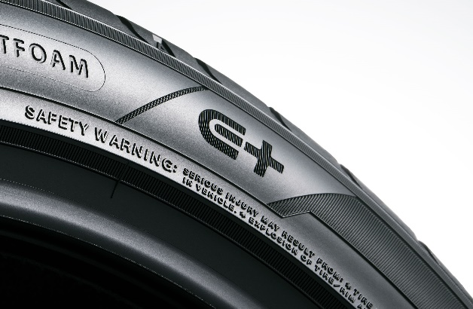
“E+” mark on an ADVAN Sport EV’s sidewall
“E+” mark

Under YOKOHAMA’s three-year (2021–2023) medium-term management plan, Yokohama Transformation 2023 (YX2023), the consumer tyre business aims to maximize the sales ratios of high-value-added YOKOHAMA tyres, namely the global flagship ADVAN brand, the GEOLANDAR brand of tyres for SUVs and pick-up trucks, and various winter tyres. In addition to strengthening its marketing of tyres to be used as OE on EVs, which require tyres made using the most advanced technologies, YOKOHAMA is utilizing the feedback received from EV makers in its development of replacement tyres as it seeks to expand its product line-up and improve the performance of all its tyres to meet new requirements in this era of dynamic change.

