26th December 2023

YOKOHAMA introduces ADVAN dB V553, a superbly quiet, premium comfort tyre

YOKOHAMA today introduces the newest tyre to its line-up - the ADVAN dB V553 is a premium comfort tyre that will provide a superbly quiet ride throughout its useful lifespan. The ADVAN dB V553 initially will be launched in Japan and Asian markets from February 2024. YOKOHAMA plans to provide the new tyre in 46 sizes, ranging from 225/45R21 95W to 155/65R14 75H.

The ADVAN dB V553 is a successor to the ADVAN dB V552 unveiled in 2017. The new tyre was developed under the concept of a “premium comfort tyre with sustainably superb quietness.”
The new ADVAN dB V553 was developed to provide drivers and passengers with a superbly quiet, comfortable, and safe ride over its entire useful lifespan. In addition to enhancing the quietness of its predecessor the ADVAN dB V552, which has been highly regarded as a quiet tyre, the ADVAN dB V553 features a construction that slows the deterioration of the tyre’s quietness and wet performance typically caused by the usual wear during a tyre’s normal lifespan.

The development of ADVAN dB V553 included creating a new tread pattern design and optimal structures for each tyre size. As a result, noise energy is reduced both when the tyre is new and after a certain amount of wear compared to its predecessor. The compound used in ADVAN dB tyres provides the tyre with an excellent balance of fuel efficiency, wet performance, and wear resistance. The tyre’s design also enhances its wear resistance and wet performance when it begins to display some degree of wear. The sidewalls of ADVAN dB V553 feature a pattern that gives an image of tranquillity in rain and a distinctly stylish logo design, which together present an image worthy of a premium comfort tyre.

The ADVAN dB V553 also bears YOKOHAMA’s proprietary “E+” mark indicating that the tyre is suitable for use on electrified vehicles. In addition to placing the “E+” mark on the tyre’s sidewall, YOKOHAMA is prominently displaying the “E+” mark in its tyre catalogues and websites so that customers can readily identify the ADVAN dB V553 as a tyre that incorporates technologies that meet the special needs of electrified vehicles, such as low electricity consumption and quietness. In addition, YOKOHAMA is using electricity derived from renewable energy sources in its production of the tyres.

Under YOKOHAMA’s three-year (2021–2023) medium-term management plan YX2023, the consumer tyre business aims to maximize the sales ratios of high-value-added YOKOHAMA tyres, namely the global flagship ADVAN brand, the GEOLANDAR brand of tyres for SUVs and pick-up trucks, and various winter tyres.

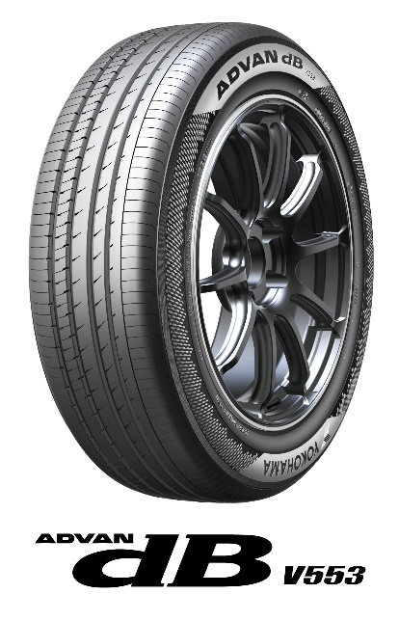

Available sizes
