10th July 2023

YOKOHAMA introduced two new products to Europe

Last week, YOKOHAMA invited participants from Europe to its Summer Tyre Test Drive Event 2023 at the famous Nürburgring in Germany. During the event, participants had the opportunity to experience the performance of YOKOHAMA´s new high performance summer tyre exclusive for EV, the ADVAN Sport EV V108, as well as the new All-Season tyre for Crossover SUV, GEOLANDAR CS 4S G061.

The ADVAN Sport EV is an ultra-high performance summer tyre for premium EVs. Based on YOKOHAMA’s ADVAN Sport V107 tyre for high-performance cars, the new ADVAN Sport EV was developed to contribute to the low electricity consumption and quietness desired by owners of EVs and other electrified vehicles. The new ADVAN Sport EV features technologies cultivated in YOKOHAMA’s development of original equipment tyres already being supplied for premium EVs and other electrified vehicles from such premium car makers as BMW and Mercedes-AMG.

In addition to the new product launch, YOKOHAMA celebrates the 45th anniversary of the ADVAN brand by showing almost the complete range of ADVAN tyres. The flagship tyre ADVAN Sport V107 was available for testing in various conditions. One of the highlights was the taxi-drive with professional racing drivers from Walkenhorst Motorsport on the Grand Prix track of the Nürburgring.

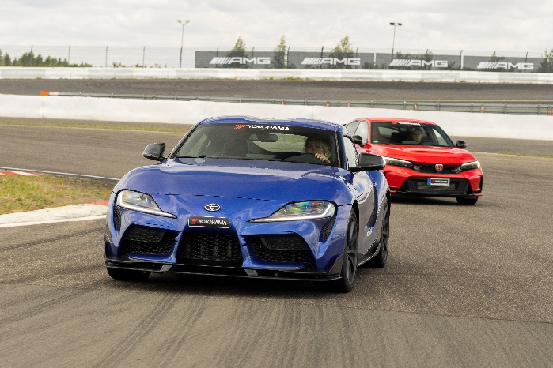
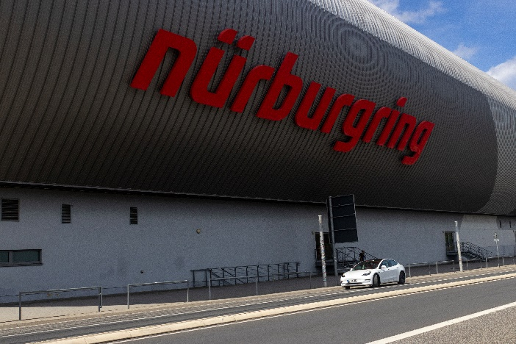
YOKOHAMA testing at the Grand Prix track of Nürburgring
YOKOHAMA´s new ADVAN Sport EV V108 tyres at the Nürburgring

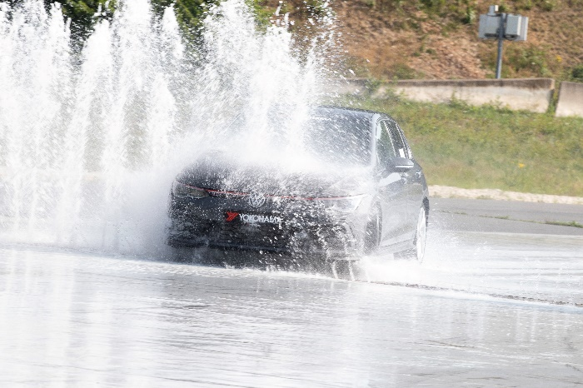
Proximity to Motorsports with Walkenhorst Motorsport´s racing & display car
YOKOHAMA performs well, also in wet conditions

