19th December 2012

**YOKOHAMA Develops Tyre Design Technology That Reduces Aerodynamic Drag on Vehicles**

Tokyo - The YOKOHAMA Rubber Co., Ltd. announced today that it has developed tyre design technology that lowers aerodynamic drag. The new technology takes the environmental contribution made by reducing rolling resistance a step further by improving the flow of air around the tyres while a vehicle is in motion in order to raise fuel efficiency.

Air flows turbulently inside the wheel wells when a vehicle is moving, and some of this air flows out alongside the vehicle and causes aerodynamic drag to worsen. YOKOHAMA has tackled this problem by pursuing research using both aerodynamic simulations and wind tunnel testing.* Aerodynamic simulation technology was developed in 2010 to enable air flow around tyres to be simulated under the conditions envisaged to be encountered in actual use (i.e., with tyres mounted in the wheel wells and revolving), and the scope of simulation is presently being expanded to include the entyre vehicle.

These simulations and wind tunnel tests resulted in a tyre design that reduces the aerodynamic drag on a vehicle. An analysis was made of a tyre (fin tyre) with fin-shaped protuberances on the side facing

inwards when mounted. The results showed that while drag on the tyre itself was worse than on a normal tyre, drag on the vehicle as a whole was considerably reduced. This was found to be attributable to changes in pressure in the wheel wells caused by the spiraling flow of air induced in the direction of the tyre’s rotation by the fins. Going forward, YOKOHAMA will conduct further research on the relationship between tyre shape and air flow, alongside assessing performance on actual vehicles, as it pursues its development of tyres that reduce the aerodynamic drag on vehicles overall as well as just improved tyre performance.

This technology was unveiled today at the 26th Computational Fluid Dynamics Symposium being held at the National Olympics Memorial Youth Centre in Tokyo until December 20, and is also to be presented at the Tyre Technology Expo 2013 in Cologne, Germany, from February 5, 2013.

*A test facility for artificially generating small-scale flows to reproduce and observe actual conditions.

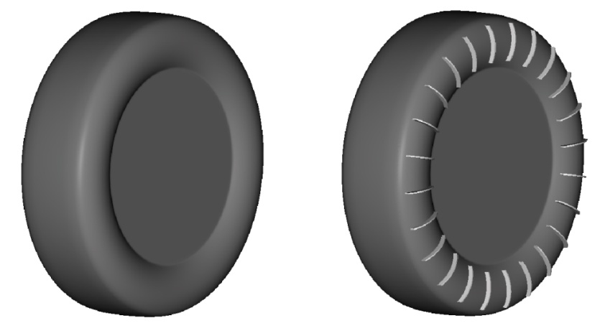

***Normal tyre (left) and fin tyre***

**Improvement in fin tyre’s drag coefficient (*C*d): results of aerodynamic simulation and wind tunnel testing (where normal tyre = 0, 1 count = 1/1000)**



**Fin tires greatly reduced vehicle aerodynamic drag in aerodynamic simulations and wind tunnel tests.**

**Air flow in wheel wells with and without fin tyres: analysis by aerodynamic simulation**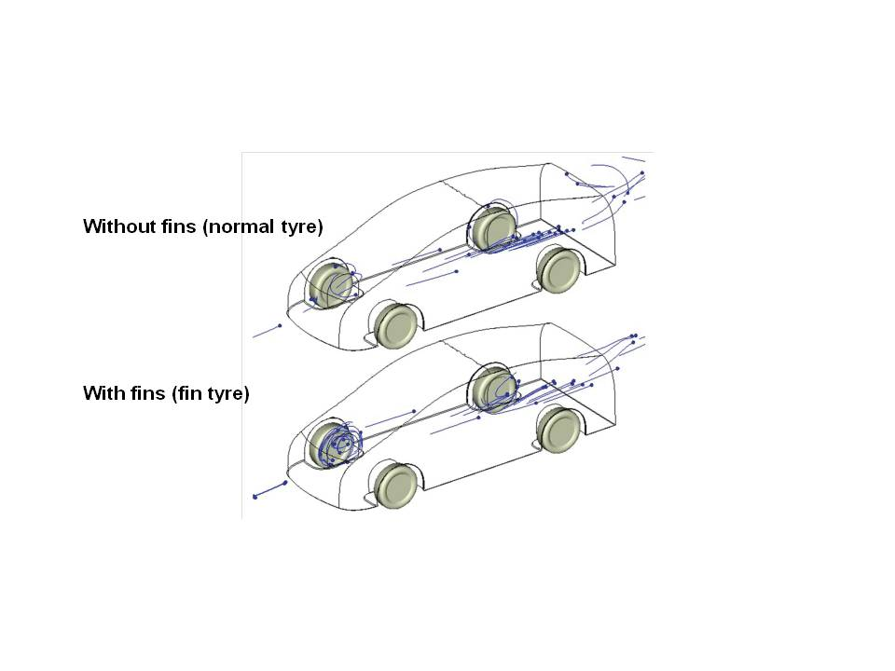

**Fin tyres greatly reduced vehicle aerodynamic drag in aerodynamic simulations and wind tunnel tests.**

**Fin tyres induce spiralling air flows in the direction of rotation that alter the pressure in the wheel well and impart forward force on the vehicle.**