20th June 2022

YOKOHAMA begins practical testing of tyre solution service for taxi companies

YOKOHAMA announced today that it has begun practical testing of its Tyre air Pressure Remote access System (TPRS) as a tyre solution service for taxi companies. The testing began in May and is being conducted together with the Company’s tyre sales subsidiary Yokohama Tire Japan Co., Ltd., and with the cooperation of Kyoto Taxi Co., Ltd., and Koshin Taxi Co. The TPRS test is being conducted using tyre air-pressure sensors developed by YOKOHAMA attached to the inner surface of tyres mounted on taxis operated by the two companies in Kyoto Prefecture and surrounding areas.

The testing seeks to verify the effect of TPRS and the air pressure sensors attached to tyres’ inner surface, which YOKOHAMA has developed as part of its response to changes in the automobile industry, such as CASE*1 and MaaS*2. TPRS and the air-pressure sensors attached to tyres’ inner surfaces enable car fleet operators and YOKOHAMA service staff to remotely monitor tyre air pressure, temperature, and vehicle location. The system greatly reduces time spent checking tyres at the start of each day and records air-pressure data. It enables early detection of slow punctures that cause gradual air leakage. It also contributes to proper tyre maintenance, helps prevent inspection irregularities, and improves fuel efficiency by maintaining proper air pressure. In addition, the system’s ability to detect tyre abnormalities in real time can help prevent accidents. Detection data is transmitted to a cloud server, enabling the taxi company’s fleet managers and YOKOHAMA’s sales offices to monitor tyre air pressure. An alarm device installed in the taxi operator’s office will notify the fleet manager when air pressure falls to a level that will reduce fuel efficiency or indicates a possible slow puncture. Unlike the conventional valve-type TPMS (Tyre Pressure Monitoring System), air-pressure sensor attached to tyres’ inner surface can be used on a wide variety of vehicles and wheels as an aftermarket part that can be used with any wheel type. YOKOHAMA previously has conducted practical testing of its TPRS for corporate cars and car-sharing companies, but the current test being conducted with taxi companies that require strict tyre management is aimed at establishing a business model that contributes to the improved safety and economical operation of taxi fleets.

The CASE and MaaS initiatives included in Yokohama Transformation 2023 (YX2023), YOKOHAMA’s medium-term management plan for fiscal years 2021–2023, include the promotion of a new tyre solutions service based on the development of a SensorTyre (Internet of Things [IoT] tyre) with sensing functionality and stronger, more flexible service capabilities. In February 2021, YOKOHAMA announced its SensorTyre Technology Vision, a medium- and long-term technological development vision for passenger car tyre sensors. The aim of this new vision is to provide continued support for the safe and sound movement of people while also addressing changes in mobility demand by providing data obtained from IoT tyres fitted with sensing functionality to drivers and operators of a diverse range of automobile-related services. To achieve the goals of this vision, YOKOHAMA is conducting practical testing with partners from various industries.

*1: An acronym for Connected, Autonomous, Shared & Services (short for car-sharing and related services, or in
some cases sharing only), and Electric (for e-cars).
*2: Mobility as a Service. The provision through packaged search, reservation, payment, and other related functions
of optimal combinations of public transport and other mobility services for addressing the mobility needs of local residents and of travellers.

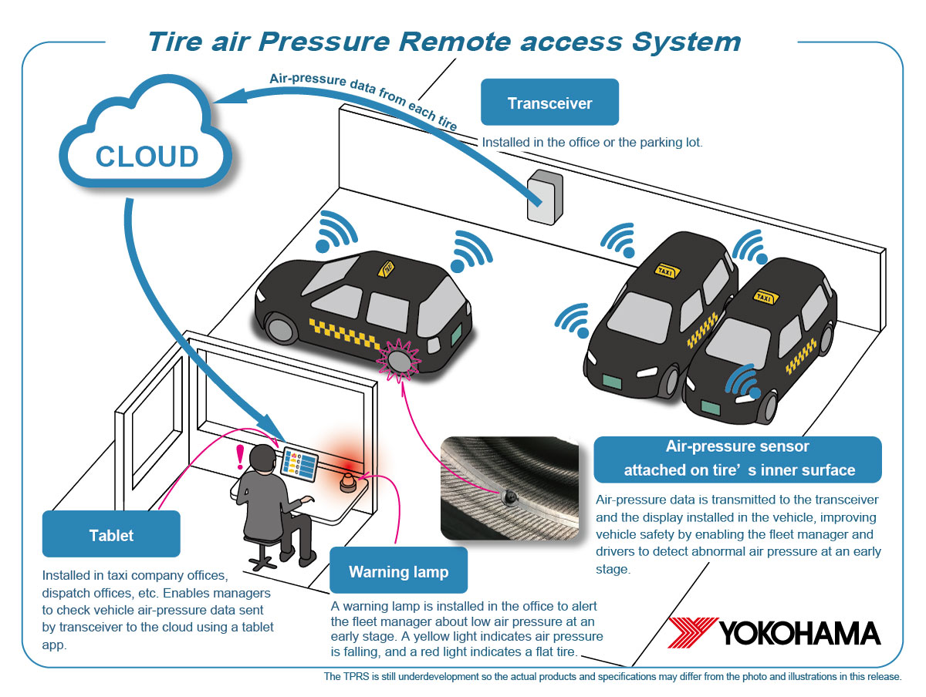
Image of the practical testing of TPRS

Partner taxi company profiles

Company: Kyoto Taxi Co., Ltd.
President: Keizo Kawamoto
Business: General passenger car transportation business (chauffeur & taxi business), general multiple passenger vehicle transportation business (buses, on-demand taxis), contracted vehicle management/operation business (facility and school buses, etc.), freight truck transportation business, substitute driver business, worker dispatching business, real estate leasing business, etc.

Company: Koshin Taxi Co.
President & Representative Director: Noriaki Hamada
Business: General passenger car transportation business

