27th April 2022

YOKOHAMA announces renewal of its floating and fixed fender global website
— More extensive product information —

YOKOHAMA announces that a new, revised global website introducing its floating and fixed fenders (https://www.y-yokohama.com/global/product/mb/fenders/), is online from today, 27th April 2022.

In addition to a new webpage design, the renewal site provides more extensive information about YOKOHAMA fenders, including its products for special applications, like the ABF-P (Air Block Fenders with Protector Panel) fender for use on docking terminals and its ultra-large fenders. The renewal website is designed to help customers to understand the performance and functionality of the fenders, with examples of actual usage, performance curve data* for each size of the ABF-P line-up, and a movie introducing the key features of YOKOHAMA’s ultra-large fenders.
*Data showing the relations between deflection & reaction force and deflection & energy absorption

YOKOHAMA developed the world’s first floating fender in 1958. Since then, more than 40,000 YOKOHAMA fenders have been used around the world. The website renewal is intended to provide a wider range of customers with more information about the superior performance and high-quality of YOKOHAMA fenders with actual usage examples. The website is also part of YOKOHAMA’s efforts, as the leading manufacturer of fenders, to contribute to improving the safety of cargo handling in the oceans.

YOKOHAMA is currently implementing its Yokohama Transformation 2023 (YX2023) medium-term management plan for fiscal years 2021–2023.The plan calls for the MB Segment to concentrate its resources in its two strongest business domains - hose & couplings and industrial products - as it aims to become a growth driver capable of generating stable profits. As part of that plan, YOKOHAMA is endeavouring to strengthen the product and brand power of its marine products line-up by strengthening its production network and maintaining their high market shares.

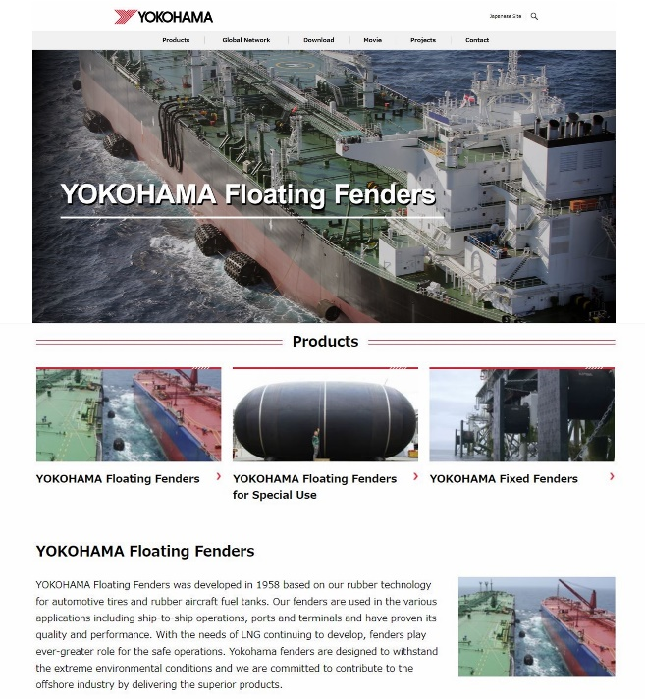
Top page of the renewed global website for YOKOHAMA floating and fixed fender

