6th Ocotober 2021

YOKOHAMA and Zenrin begin practical testing of tyre sensor attached to tyre’s inner surface

YOKOHAMA announced today that is has begun practical testing of a tyre sensor attached to the tyre’s inner surface. Testing is being conducted in collaboration with Zenrin on a nationwide basis using test vehicles outfitted with sensor-attached tyres.

The tests are being conducted using a tyre sensor being developed by YOKOHAMA and an in-vehicle device developed by Alps Alpine Co., Ltd., that has been attached to the test vehicles with Zenrin’s cooperation. The practical tests will confirm the durability of the sensors attached to the tyres’ inner surface and the ability of a newly developed system (Tyre air Pressure Remote access System = TPRS) to remotely monitor tyre pressure using the in-vehicle device. In addition, YOKOHAMA aims to realize a new value-added tyre-related business that provides tyre pressure information and GPS location data along with Zenrin's abundant map information.

YOKOHAMA’s TPRS is a response to changes in the automobile industry, such as CASE*1 and MaaS*2. The current practical test of the system aims to determine its merits for vehicle maintenance staff, including labour-saving effects during tyre maintenance, more precise tyre management, and more efficient tyre maintenance planning. The test will also consider the system’s benefits for vehicle owners, such as its contribution to safe vehicle operation and improved fuel efficiency. Using TPRS, YOKOHAMA aims to establish a new business model that contributes to driver safety and enhances the economic efficiency of vehicle operation.

TPRS enables real-time remote monitoring of tyre pressure, temperature, and vehicle location. In addition to contributing to significant labour-saving during tyre maintenance, TPRS will help prevent irregularities in inspection results, detect potential accident-causing abnormalities, and improve fuel efficiency by ensuring maintenance of proper tyre pressure, etc. System data is saved in a cloud server in real time.

The CASE and MaaS initiatives included in Yokohama Transformation 2023 (YX2023), YOKOHAMA’s medium-term management plan for fiscal years 2021–2023, include the promotion of a new tyre solutions service based on the development of a SensorTyre (Internet of Things [IoT] tyre) with sensing functionality and stronger, more flexible service capabilities. In February 2021, YOKOHAMA announced its SensorTyre Technology Vision, a medium- and long-term technological development vision for passenger car tyre sensors. The aim of this new vision is to provide continued support for the safe and sound movement of people while also addressing changes in mobility demand by providing data obtained from IoT tyres fitted with sensing functionality to drivers and operators of a diverse range of automobile-related services. To achieve the goals of this vision, YOKOHAMA is conducting practical testing with partners from various industries.

*1: An acronym for Connected, Autonomous, Shared & Services (short for car-sharing and related services, or in some cases sharing only), and Electric (for e-cars).

*2: Mobility as a Service. The provision through packaged search, reservation, payment, and other related functions of optimal combinations of public transport and other mobility services for addressing the mobility needs of local residents and of travellers.

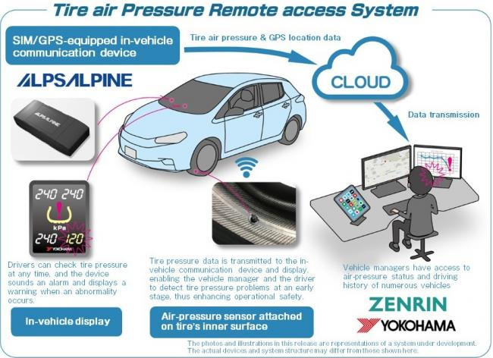
Tyre Air Pressure Remote Access System

