24th January 2024

YOKOHAMA and RAOT hold their sixth joint seminar event in support of natural rubber farmers in Thailand

YOKOHAMA announced today that, together with the Surat Thani branch of the Rubber Authority of Thailand (RAOT)*, it held a seminar event in December 2023 to help Thai natural rubber farmers improve the quality and productivity of their natural rubber. Seventy farm households in the Surat Thani area participated in the event. Each participating household received a complimentary 250 kg of fertilizer developed using RAOT’s specialist knowledge. The seminar is the sixth held by YOKOHAMA and RAOT since 2020.
*A state enterprise under the jurisdiction of Thailand's Ministry of Agriculture and Cooperatives (MOAC)

In January 2020, YOKOHAMA signed a Memorandum of Understanding (MOU) with the RAOT to cooperate in efforts to provide economic support for Thai natural rubber farmers and to improve traceability to ensure transparency and soundness of the natural rubber supply chain. The MOU and events held under it are concrete actions based on YOKOHAMA’s “Procurement Policy for Sustainable Natural Rubber.” This seminar event was held in the Surat Thani area, home to YOKOHAMA’s Thai natural rubber processing company Y.T. Rubber Co., Ltd., as part of support for farmers under the MOU. The farmers who received fertilizer are cooperating in follow-up surveys on its effect on the physical properties and productivity of their natural rubber.

A founding member of the Global Platform for Sustainable Natural Rubber (GPSNR), YOKOHAMA revised its “Procurement Policy for Sustainable Natural Rubber" in September 2021 and is strengthening its collaboration with GPSNR activities. The recent seminar event in Thailand reflects the principle of “Support for suppliers, including small-scale farmers, and other parties involved in the supply chain” set forth in the Procurement Policy. YOKOHAMA will continue to implement and announce initiatives in line with the action guidelines stipulated in this policy. YOKOHAMA also is endeavouring to achieve the Sustainable Development Goals (SDGs) adopted by the United Nations. As part of these efforts, the Yokohama Rubber Group is promoting the procurement of sustainable raw materials, including natural rubber.

Under the slogan for sustainability management “Caring for the Future”, YOKOHAMA is creating shared value by addressing social issues through its business activities.

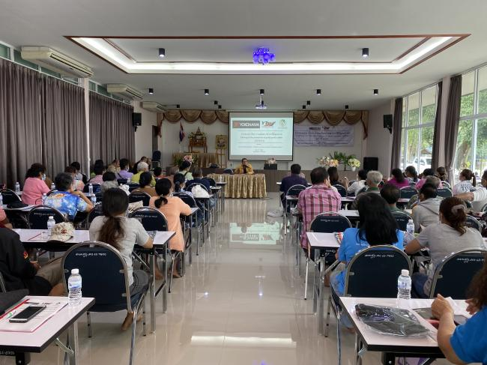
A moment from the natural rubber seminar

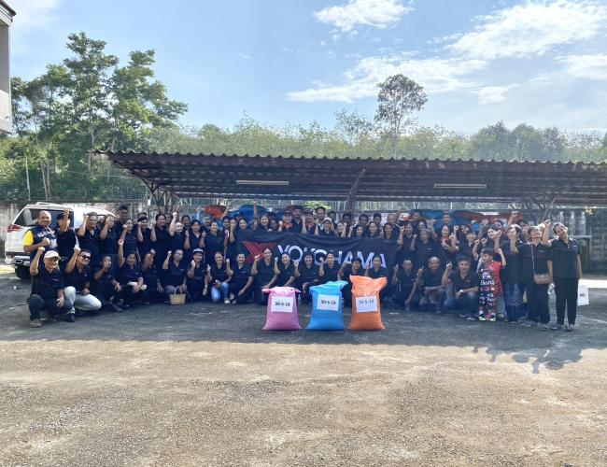
A commemorative photo of the natural rubber farmers behind the fertilizer they received

