5th April 2024

YOKOHAMA and Mercedes-AMG Customer Racing’s Haupt Racing Team sign partnership agreement

YOKOHAMA announces that it has signed a partnership agreement with Mercedes-AMG Customer Racing’s Haupt Racing Team (HRT). As part of the ADVAN CHALLENGE that seeks to maximize sales of ADVAN tyres, YOKOHAMA is aiming for victories at the Nürburgring 24-Hour Race and Nürburgring Langstrecken Serie (NLS) by supplying its ADVAN racing tyres for the Mercedes-AMG GT3 being entered in those races by HRT.

HRT was founded in July 2020 by racing driver and entrepreneur Hubert Haupt and has quickly established itself as a force to be reckoned with in international GT3 racing. HRT secured the drivers’ championship in the Deutsche Tourenwagen Masters (DTM) series in just its second motorsport season. In 2023, the team celebrated its most successful season to date and competed in the DTM, NLS, the Fanatec GT World Challenge Europe and the 24-hour races at the Nürburgring and Spa-Francorchamps - in some cases with works support from Mercedes-AMG. HRT GmbH is based in the Drees industrial estate in the immediate vicinity of the Nürburgring. HRT is also involved in professional sim racing and is a sought-after partner for technical development projects and motorsport events of all kinds.

Over the years, YOKOHAMA has supported many teams participating in the Nürburgring 24-Hour Race, a motorsports event where the world’s leading tyre manufacturers display their tyres’ performance under the most demanding conditions as part of their intense global competition. Cars equipped with YOKOHAMA tyres have won the overall championship three times. In last year’s NLS, cars equipped with YOKOHAMA tyres turned in a dominant performance, winning five of the nine races as well as the NLS Speed Trophy and the NIMEX Team Trophy in the NLS highest SP9 Pro Class.

[About new medium-term management plan YX2026]
The consumer tyre strategy in YOKOHAMA’s new three-year (2024–2026) medium-term management plan, Yokohama Transformation 2026 (YX2026), aims to maximize the sales ratios of high-value-added tyres by expanding sales of YOKOHAMA’s global flagship ADVAN brand, the GEOLANDAR brand of tyres for SUVs and pick-up trucks, winter tyres, and 18-inch and larger tyres. YOKOHAMA positions participation in motorsports activities as crucial to its effort to further strengthen the ADVAN and GEOLANDAR brands. YOKOHAMA therefore is again participating in a wide variety of motorsports events around the globe, from top-category to grassroots events.
Following is a list of the main events YOKOHAMA will be participating in this year. We will post event updates and results on YOKOHAMA’s dedicated motorsports website and on our official motorsports SNS sites.

[Yokohama Rubber official motorsports website and SNS]: Website: https://www.y-yokohama.com/cp/global/motorsports/
X: https://twitter.com/yokohama_sport/
Facebook: https://www.facebook.com/YRCmotorsports/
Instagram: https://www.instagram.com/yokohama_motorsports/

Team: Haupt Racing Team
Car: Mercedes-AMG GT3
Tyres:
ADVAN A005 (for dry conditions); Sizes: front 300/680R18, rear 330/710R18
ADVAN A006 (for wet conditions); Sizes: front 300/680R18, rear 320/710R18

[Race schedule (As of date of this release)]
April 6 (Sat) – April 7 (Sun): Nürburgring Langstrecken Serie (NLS) Rounds 1 & 2
April 13 (Sat) –April 14 (Sun): Nürburgring 24-Hour Race Two qualifying races
May 30 (Thu) – June 2 (Sun): Nürburgring 24-Hour Race Final

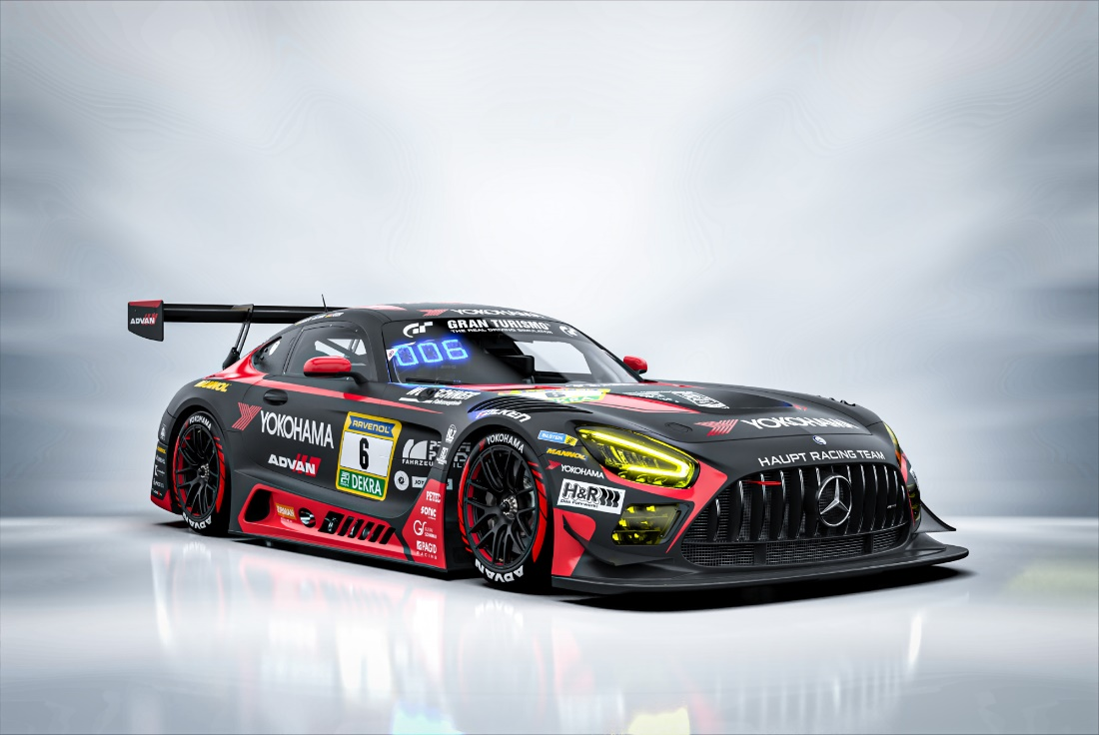

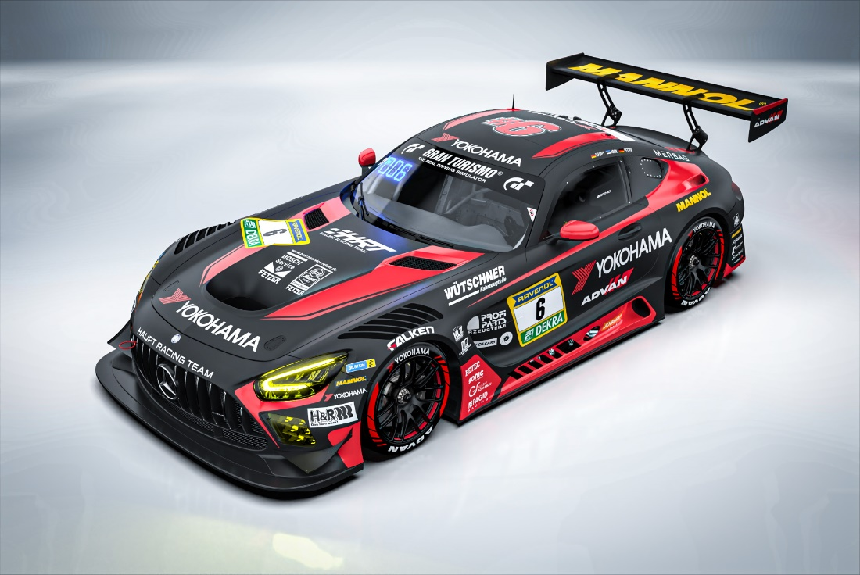
Mercedes-AMG GT3 planned design
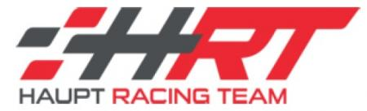
Haupt Racing Team logo

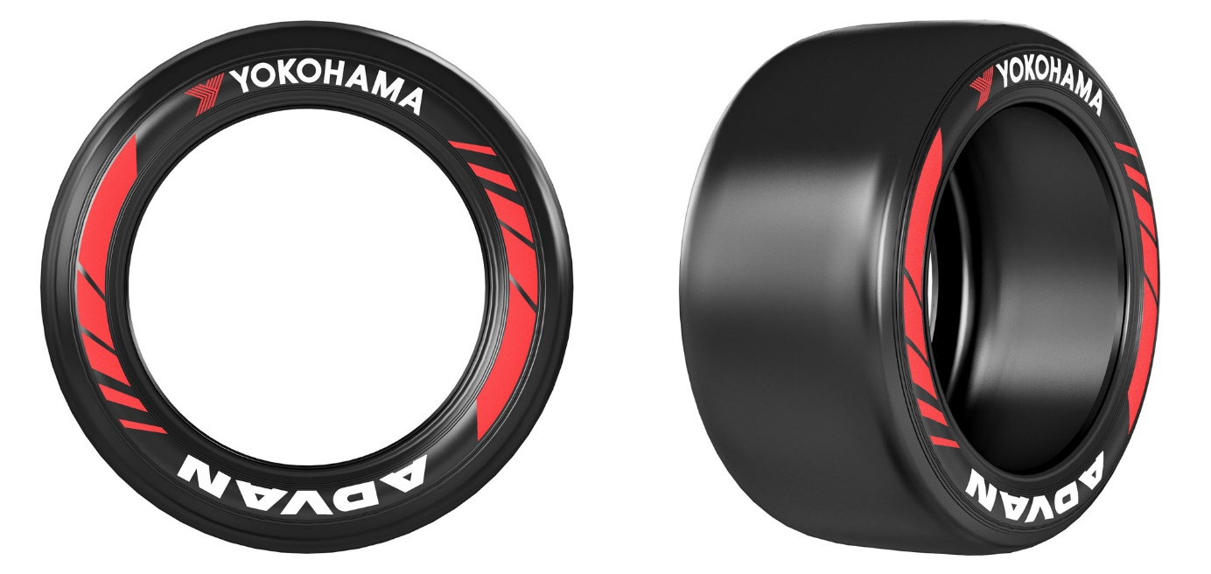

ADVAN A005

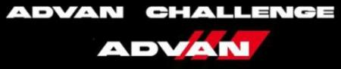
ADVAN CHALLENGE logo

