9th December 2022

YOKOHAMA and Indonesian natural rubber supplier sign MOU and hold event for natural rubber farmers

YOKOHAMA announced today that on 1st December 2022 it signed a Memorandum of Understanding (MOU) with PT Kirana Megatara Tbk, a major natural rubber supplier in Indonesia, to cooperate in efforts to provide economic support for Indonesian natural rubber farmers and to improve traceability to ensure transparency and soundness of the natural rubber supply chain. The MOU with Kirana Megatara is the latest concrete action taken under YOKOHAMA’s “Procurement Policy for Sustainable Natural Rubber.” In conjunction with the signing of the MOU, the two companies held a seminar event targeted at improving the quality and productivity of natural rubber in Indonesia.

The event, attended by about 50 small-scale farmers affiliated with Kirana Megatara and local government officials, featured a tapping^{*1} contest and a quiz on agricultural technology. The farmers attending the event received a complementary supply of fertilizer and natural rubber coagulants.
*1 Scratching the bark of a Para rubber tree to extract latex sap, which contains natural rubber.

Demand for tyres and consequently natural rubber - the core raw material used in tyre production - has been expanding steadily as the world’s population grows and mobility technologies become more advanced. However, this growth in demand has raised concerns about a host of problems, including unlawful deforestation, land exploitation, human rights violations, and adverse effects on biodiversity, in countries and regions where natural rubber is produced. To help resolve these problems, YOKOHAMA has been participating since 2017 in the Sustainable Natural Rubber Initiative (SNR-i) advocated by the International Rubber Study Group^{*2}. In addition, the company has been an active founding member of the Global Platform for Sustainable Natural Rubber (GPSNR) since its launch in 2018 and has been strengthening its collaborations with GPSNR activities since revising its “Procurement Policy for Sustainable Natural Rubber” in 2021.
*2 An intergovernmental organization comprising governments of countries engaged in the production and consumption of natural and synthetic rubber

YOKOHAMA previously signed a similar MOU with the Rubber Authority of Thailand (RAOT), and the two partners continue to work together to support natural rubber farmers in Thailand. YOKOHAMA also is engaged in many other activities targeted at realizing the sustainability of natural rubber, including “Suppliers’ Day” events promoting the exchange of information with natural rubber farmers, joint research with local universities aimed at improving the quality and productivity of natural rubber, and the promotion of more widespread use of agroforestry to enable natural rubber farmers to secure more stable income.

The sustainability initiatives included in Yokohama Transformation 2023 (YX2023), YOKOHAMA’s medium-term management plan for fiscal years 2021–2023, are based on the concept of “Caring for the Future.” By implementing sustainability initiatives under this concept, YOKOHAMA is endeavouring to help resolve social issues through its business activities.

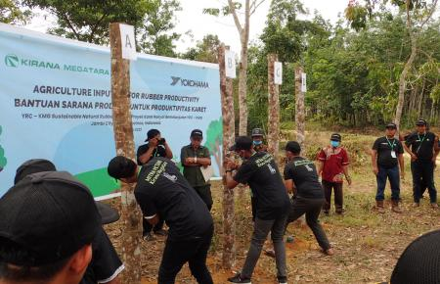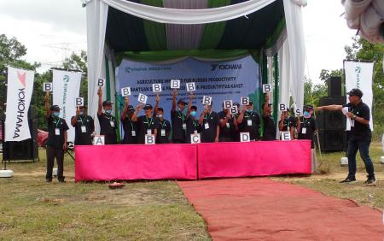
A scene of a tapping contest at the seminar event A scene of a quiz on agricultural technology at the seminar event

